Year 7 Calendar 2025

<<Year 7 planner HUMS 2025.docx>>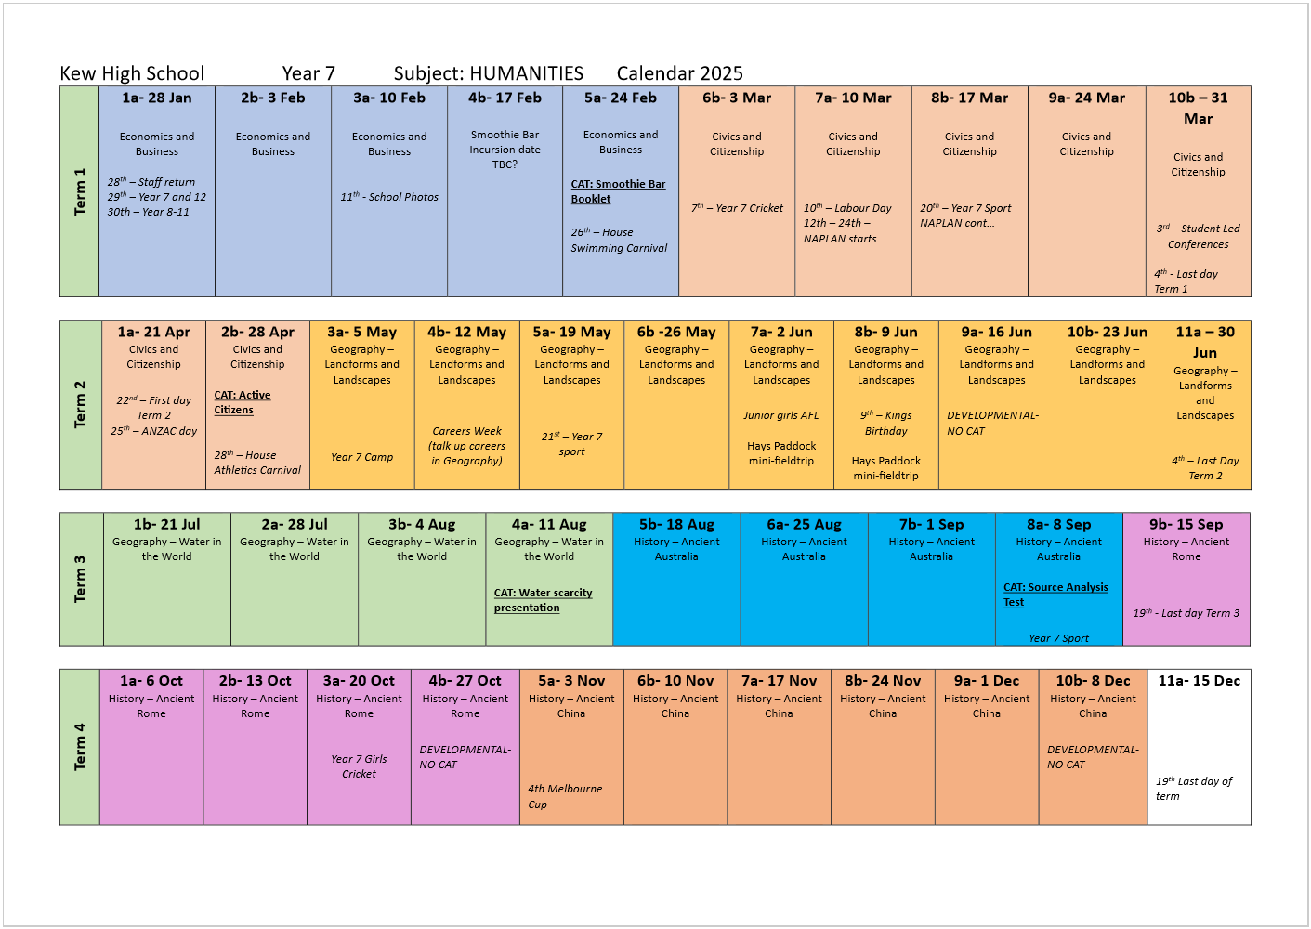

Vic Curriculum
Friday, 15 December 2023
9:54 AM

VC2.0 (updated 2026)
  - the classification of water as a renewable resource, the forms that it takes as a resource in the water cycle, and the ways in which flows of water connect and change places VC2HG8K01
  - the environmental, economic, cultural, spiritual and aesthetic uses and value of water, including for Aboriginal and Torres Strait Islander Peoples and peoples of the Asia region VC2HG8K02
  - the distribution and variability of Australia’s water resources and the forecasted impacts of climate change on them VC2HG8K03
  - the nature of water scarcity and ways of overcoming it, with examples from Australia, and West Asia and/or North Africa VC2HG8K04
  - the causes of, impacts of and responses to an atmospheric or hydrometeorological hazard VC2HG8K05

https://f10.vcaa.vic.edu.au/learning-areas/humanities/geography/curriculum?level=7%E2%80%938&view=focus

Unit 2 WATER IN THE WORLD
 | 6 | 7 | 8 | 9
Patterns & trends | I can identify a relevant environmental pattern (spatial distribution) | I can outline significant environmental patterns (spatial distributions) | I can describe significant environmental patterns (spatial distributions) | I can explain significant environmental patterns (spatial distributions)
Interconnection | I can identify major interconnections within and between places | I can describe major interconnections within and between places | I can explain major interconnections within and between places and describe changes to these places | I can analyse major interconnections within and between places with discussion of significant changes over time | I can analyse major interconnections within and between places and explain changes over time and at different scales | I can analyse major interconnections within and between places over time and at different scales AND evaluate the resulting changes

Topic 1 - Natural Resources
Saturday, 16 June 2018
12:02 PM

Additional ideas:

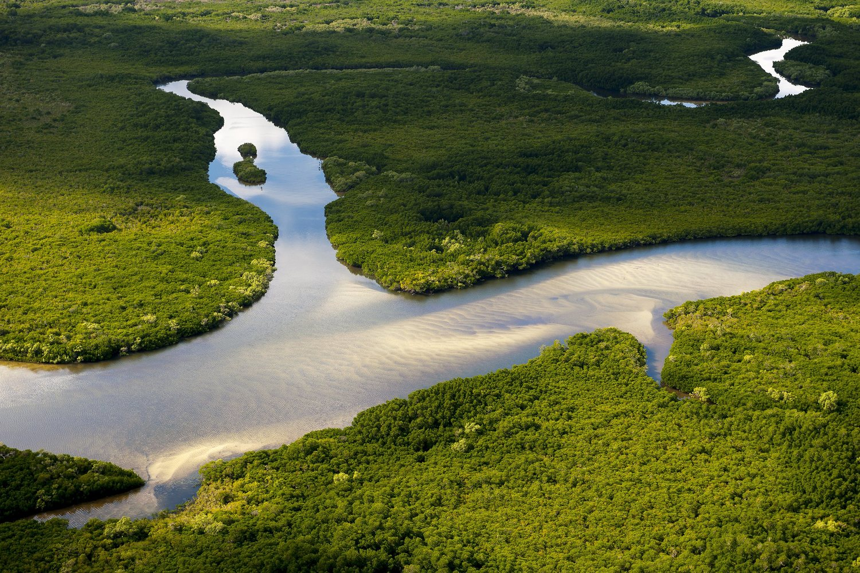

Have you ever stopped to think about the resources you need to survive every day? Fortunately, the Earth supplies us with the natural resources we need for our food, shelter, clothing, and energy for our homes and factories. These resources include water, fossil fuels and mineral deposits. However, access to these supplies is not distributed equally around the planet, and attitudes towards them may differ or change over time. As the global population increases, great damage is being done to the environment as a result of using these resources. Moreover, we need to carefully manage our use of them to ensure that these resources are available for use in the future.

1.1 The Water Cycle
Lesson Focus: What is the water cycle?

Learning intention | To describe and explain types of rainfall and the stages of the water cycle.  To describe different types of rainfall.  To describe Australia's rainfall distribution using PQE method.
Success criteria | I can explain the water cycle.  I can explain and distinguish the different types of rainfall  I can explain Australia's rainfall distribution using PQE method.
Content for Self-Assessment | Map and Data Analyses

- Engage: Play and Watch (hook)

The Great Aqua Adventure: Crash Course Kids #24.1

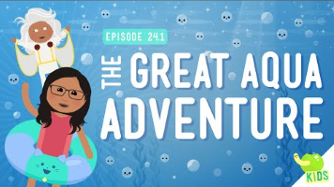

- Discover and develop

Water is one of our most precious environmental resources. Without it, nothing can survive. It is an essential, renewable resource that occurs naturally on Earth. It can exist as a solid (such as ice in a glacier), a liquid (such as water in a river) or a gas (such as steam). Fresh water is an available resource when in liquid form and a potential resource as a gas or a solid. Liquid water is constantly being recycled through the atmosphere, rivers and oceans in a natural system known as the water cycle.

Write a definition for each of these words: precipitation, condensation and evaporation.
Word | Definition
Precipitation
Condensation
Evaporation
Transpiration

Draw the Water Cycle in your work books.
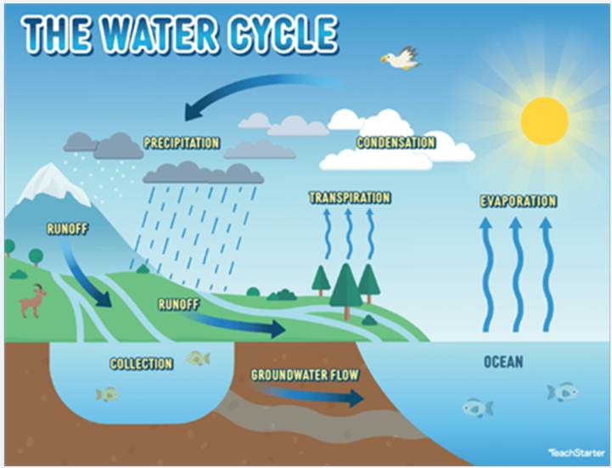

Include the following words in your picture:

Evaporation
Precipitation
Condensation
Transpiration

Take a look at the Urban Water Cycle.
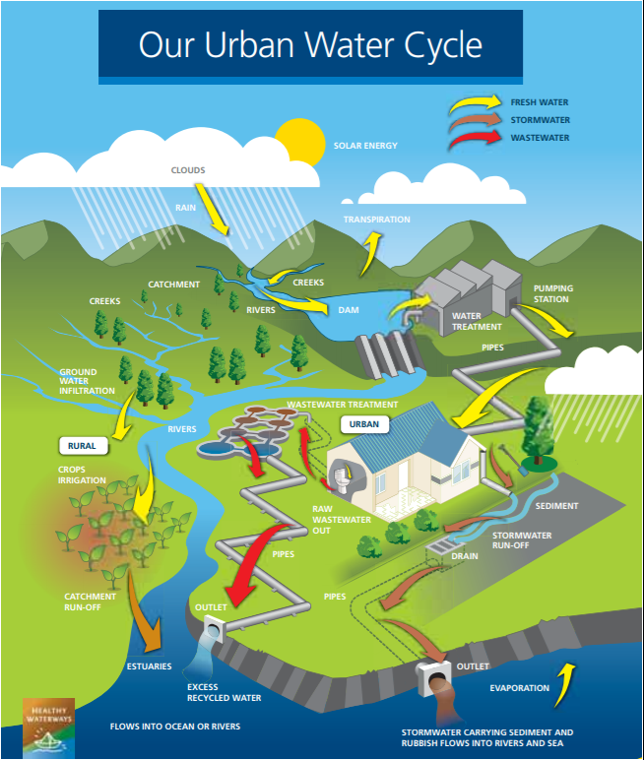

Answer the following questions:
- Describe the connection between fresh water, storm water and waste water.

- What are the potential effects on people and the environment when using this kind of water management?

- What is one similarity between the Water Cycle and the Urban Water Cycle

- What is one difference between the Water Cycle and the Urban Water Cycle

- Apply
PQE stands for Pattern, Quantify and Exception. When looking at a map or graph, in order to determine the trends and distribution shown, you can use this method to complete your analysis of the graph.

Referring to the graph below - complete a PQE and use the table to guide you in completing it.
P - requires you to look at the pattern and trends in the information. Think: if you had to describe general consistencies, how would you describe that?
Q - requires you to numerically justify the pattern you have observed using data from the information provided. Think: if you had to support the pattern you identified, what data could you include to support it?
E - requires you to find the exceptions to the pattern, what are the outliers? Think: if there is a pattern that isn't consistent with the rest, what is it?

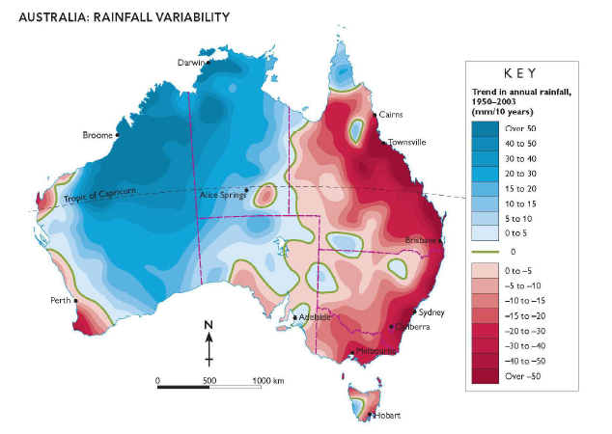

PQE | Sentence Starters (select one) | Your Response
Pattern | - The pattern shown…  - The trend of…  - Consistent across Australia is…
Quantify | -This is shown by…  -This is evident as…
Exception | - The exception to this is…  - The outlier to this is…

- Review and Reflect

Kahoot - Fun water facts https://create.kahoot.it/v2/share/amazing-water-facts/bb115294-ba7c-4388-bd2f-53666deb21d8

Additional Activities- Extension Water Cycle Game - Fun, 20 minutes, gets students moving:
<<Water Cycle Game.pdf>>

Printable worksheet of this lesson:
<<Water_Cycle_Worksheet.docx>>

1.2 Sustainable use of water

Learning Intention | Explain different types of resources as either renewable or non-renewable  Describe the classification of water resources  Analyse maps and other geographic data to learn more about water resources
Success criteria | I can classify resources as renewable and non-renewable.  I can explain why water is considered a renewable resource.  I can make connections between climate factors (temperature and precipitation), water resource accessibility, and population density.  I can describe patterns, quantify them, and point out exceptions in maps, graphs, charts, or tables.
Content for Self-Assessment | Place and Map & Data Analyses

- Engage: Play Tragedy of the Commons Game https://www.sciencefriday.com/educational-resources/one-for-all-a-natural-resources-game/

Arrange students in a circle, explain the game simulates shared resources, place 30 chips in the centre, read the rules, play music and let students take chips, stop music and double remaining chips (max 30), repeat until pool is depleted or strategies form, discuss outcomes, restart if needed, allow strategy discussion, add new students to simulate growth, continue and observe, finish with a discussion on real-world resource use.

Basic discussion:
• What happened to the resource pool?
• How did strategy or cooperation change the outcome?
• How does this relate to the use of real-world resources?

<<Rules discu defin.pptx>>
PowerPoint containing:
- Game Rules
- Extended discussion questions (for AFTER the game)
- Definitions of 'resource', 'natural resource' etc for task below

- Discover and Develop

Activity 1 - What is a resource?

Definitions:
Resource | Anything used to meet human needs, wants such as water minerals or energy.
Natural resource | Materials or substances that …
Renewable resource | A resource that can …
Non-renewable resource | A resource that cannot …
Recyclable resource | A resource that can …

Diagram:

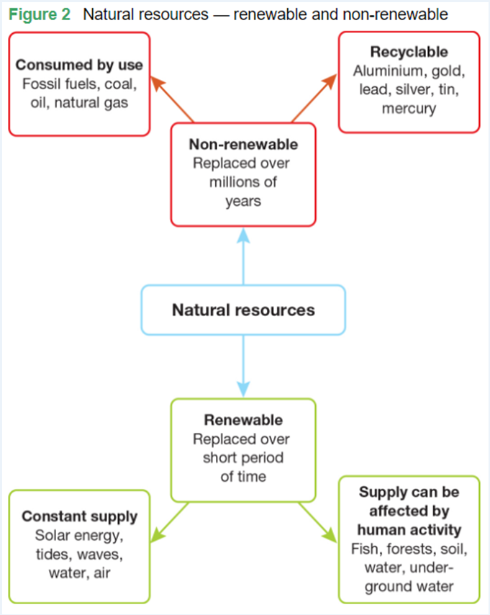

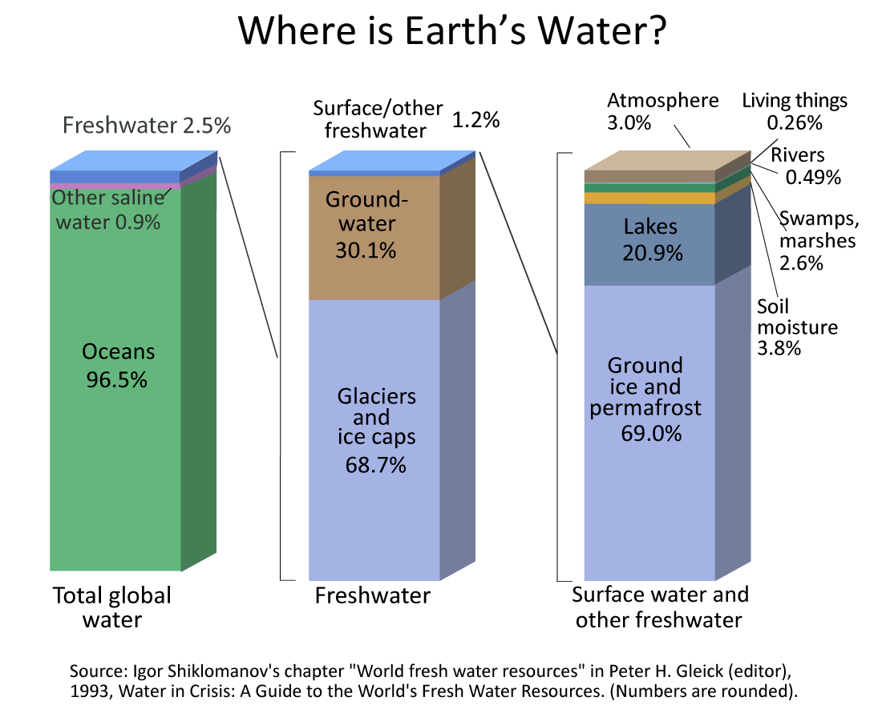

Study the diagram above and answer the following questions:
Choose 4 sources of water and describe how they may be used. | _{Example:}  Oceans - fishing, swimming, surfing, wave energy, regulates climate by keeping temperature steady.
Make a prediction about how global warming will affect our use of these sources of water
Discuss why water in glaciers, ice caps and groundwater might be hard to access.

Map Symbols:

Map symbols are icons or graphics located in a key or legend on the side of a map. They represent different features, such as rivers, mountains, roads, and landmarks, making it easier to read and understand the map's information.

Check your understanding:

Why do we use map symbols?

- Apply- Explain Diverse Characteristics of Places.

Teachers please print in colour and A3
<<1.2 Sustainable Use of Water.docx>>

Figure 1. A map portraying the natural resources that each country has.

Using the Map and Legend in figure 1, answer the following questions:

Name three countries that have coal
1.
2.
3.

Name a country that has Minerals but no energy resources

List the energy resources and minerals in Australia
1.
2.
3.
4.
5.
6.
7.
8.
9.

Using your ePen, draw a map symbol of a mineral that is not listed in the legend.

Research and list which countries have that mineral.

- Review- Exit Ticket

In pairs, discuss how we can use more renewable resources in Australia. Share your answers with the rest of class.

Extension - Map and Data Analyses: More detailed maps of Australia's minerals and energy resource.

Have a look at the following two maps and see if you can locate regions of Australia that produce a lot of mineral resources and a lot of energy resources

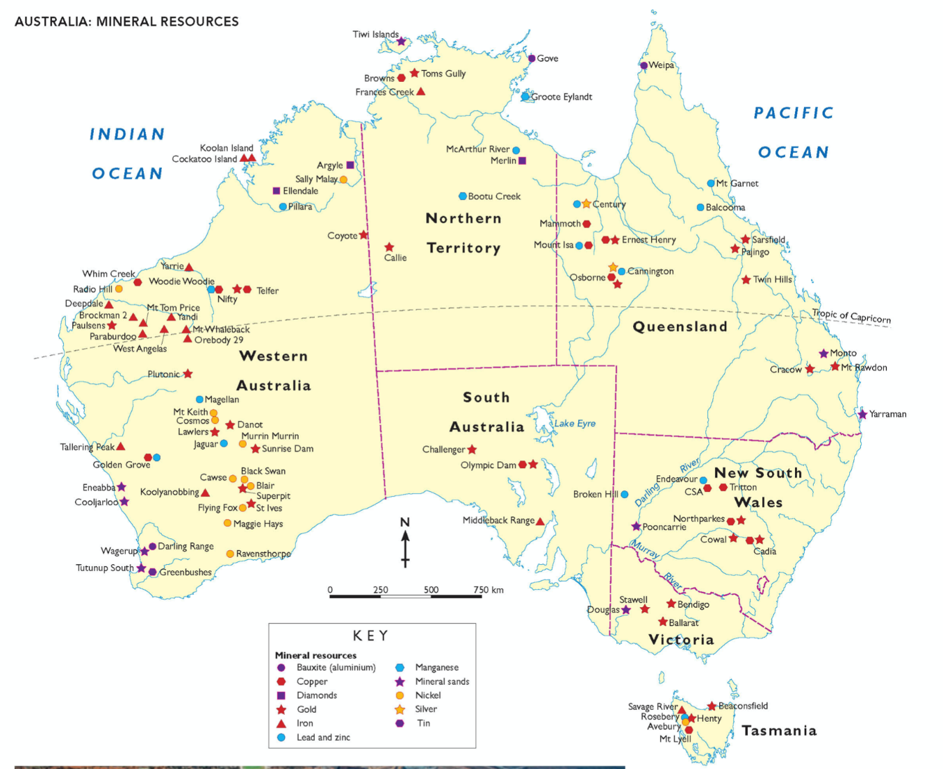

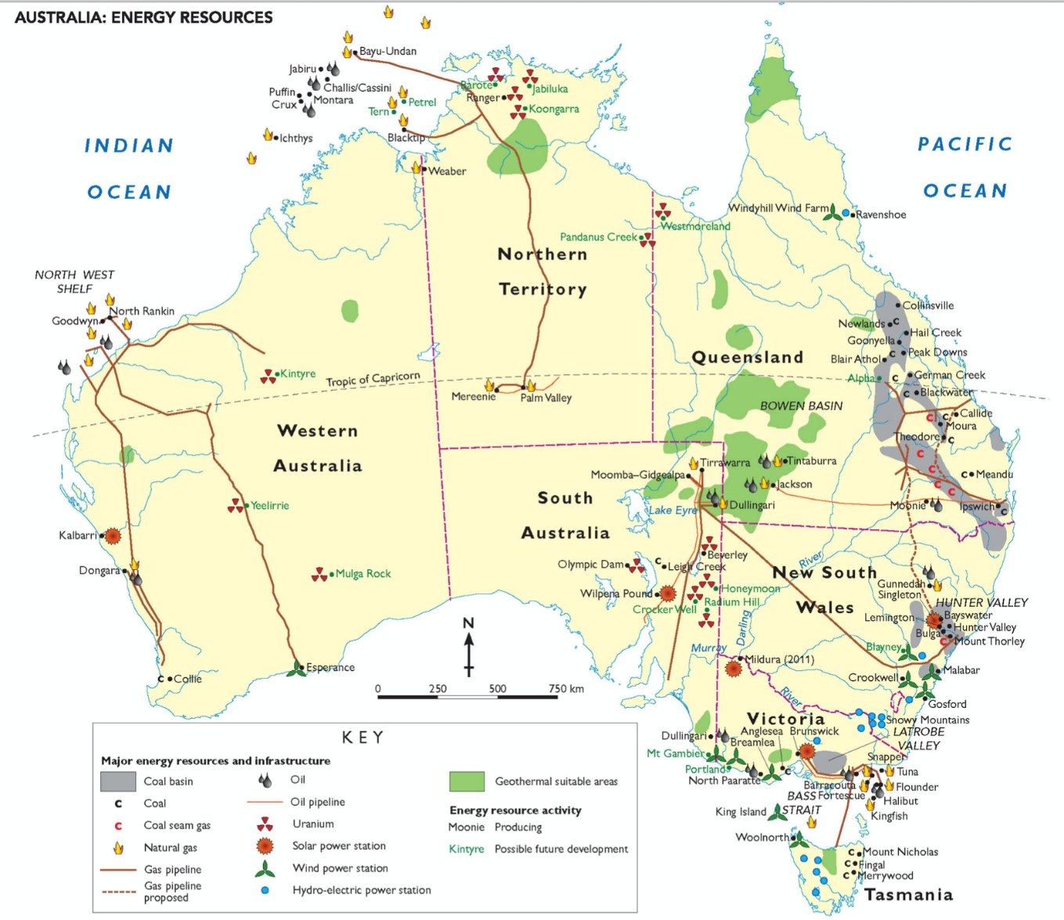

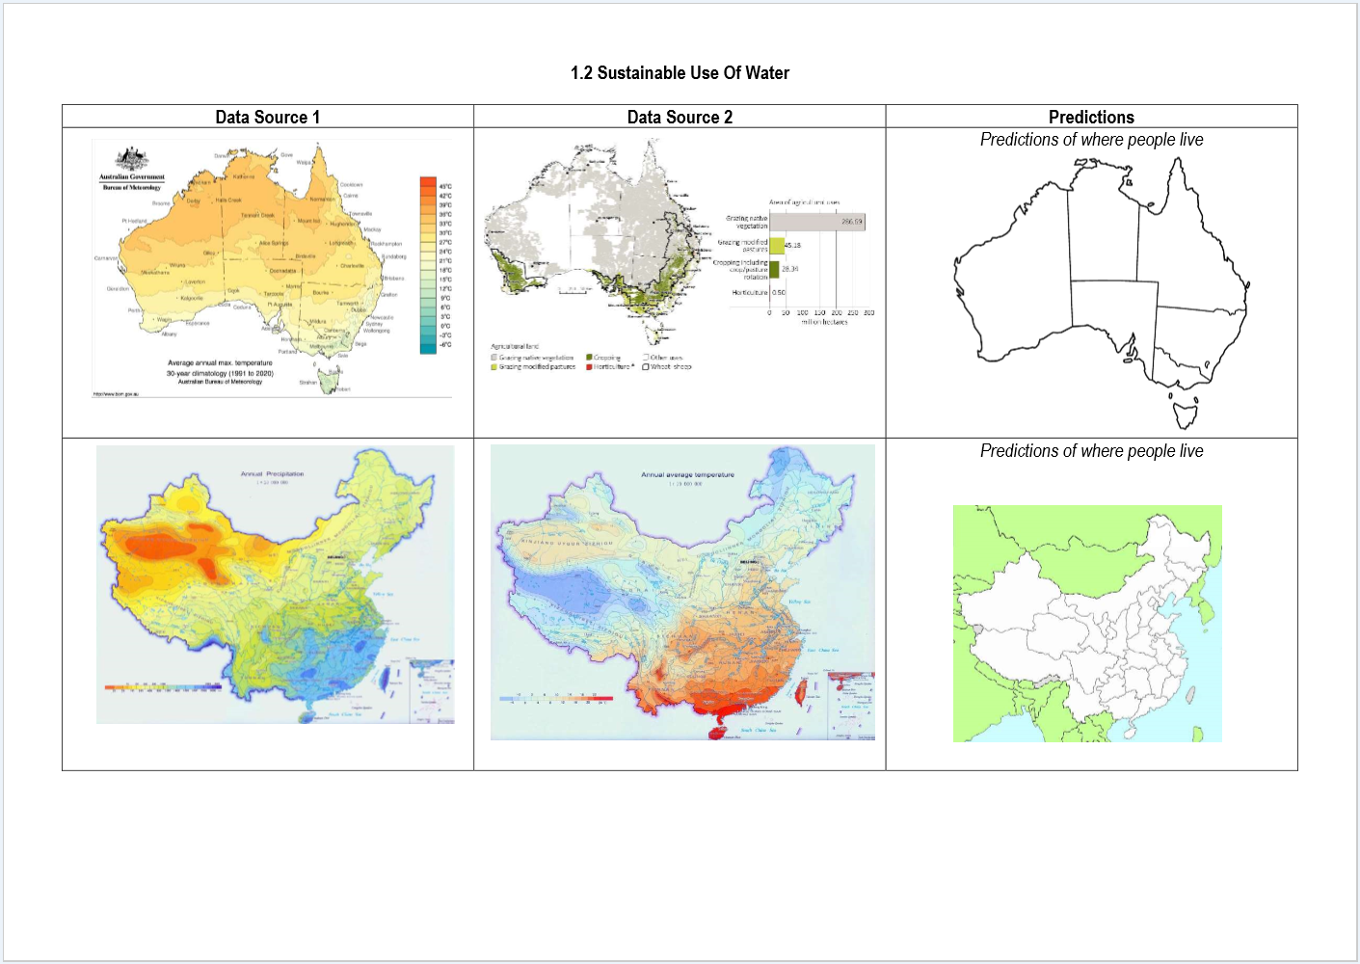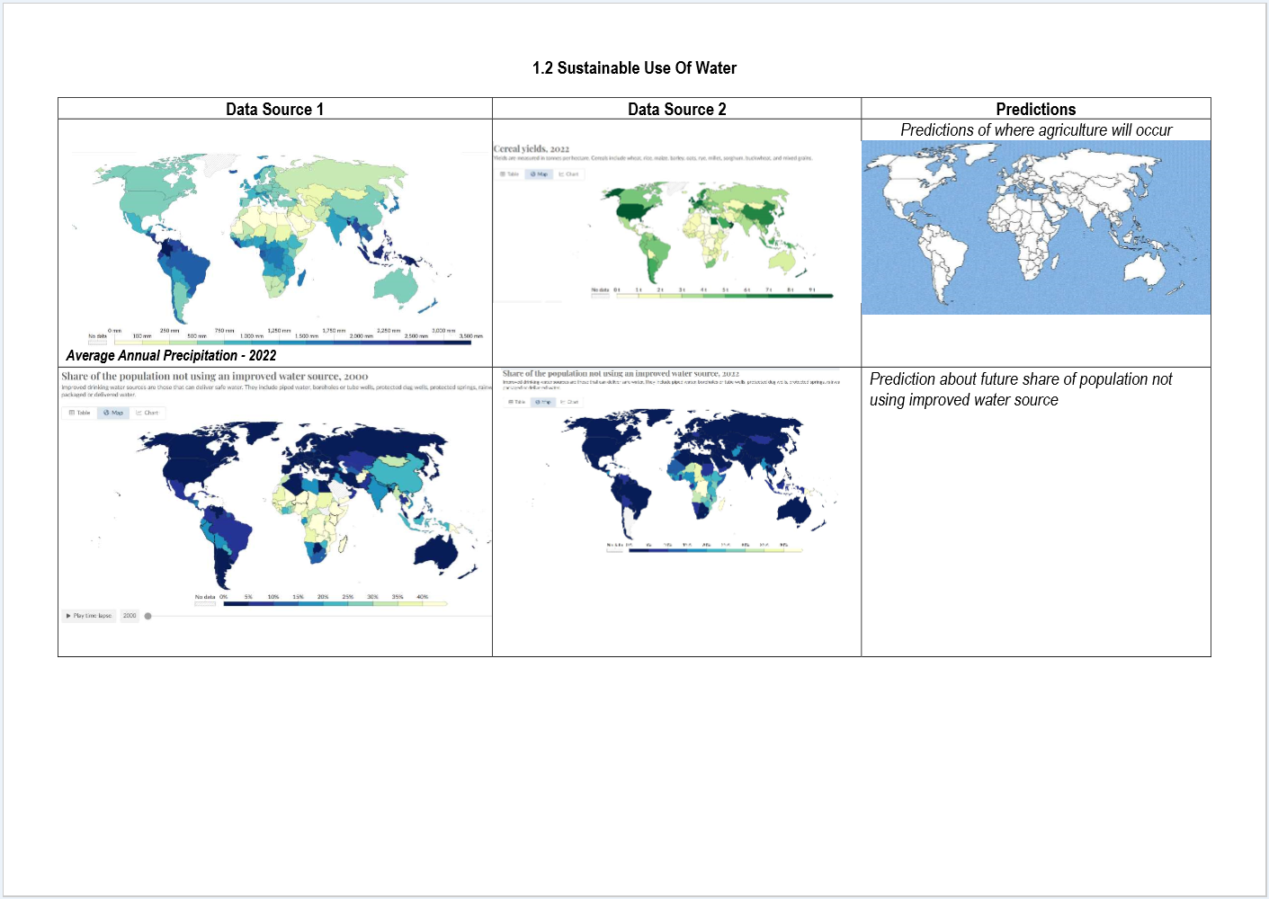

 | Level 6 | Level 7 | Level 8 | Level 9 | Level 10 | Level 11
1.1 Characteristics of place | I can identify diverse characteristics of places. | I can explain diverse characteristics of places. | I can explain processes that influence characteristics of places. | I can predict changes in the characteristics of places over time. | I can identify the implications of change for the future. | I can synthesise multiple data sources to provide analysis about the predicted changes.
2.1 Map and Data Analyses | I can identify the key features of a map (BOLTSS). | I can use geographical language to interpret increases, decreases or trends in maps, graphs, charts, or tables. | I can describe patterns, quantify them, and point out exceptions in maps, graphs, charts, or tables. | I can use social, historical, environmental, economic, political or technological factors (SHEEPT) to explain trends in maps, graphs, charts, or tables. | I can analyse relationships between multiple sources of geographical data. | I can analyse and draw reasoned conclusions from independently collected sources of geographical data.

1.3 Australia's Natural Resources
Saturday, 16 June 2018
12:01 PM
Learning intention | To explain the importance of natural resources to Australia
Success criteria | I can identify major energy resources in regions of Australia  I can explain and describe the use and importance of resources in Australia  I can appraise my knowledge of Australia's resources with a peer or family member
Content for Self-Assessment | Place & Map and Data Analyses

- Engage: Which natural resources are abundant in Australia?

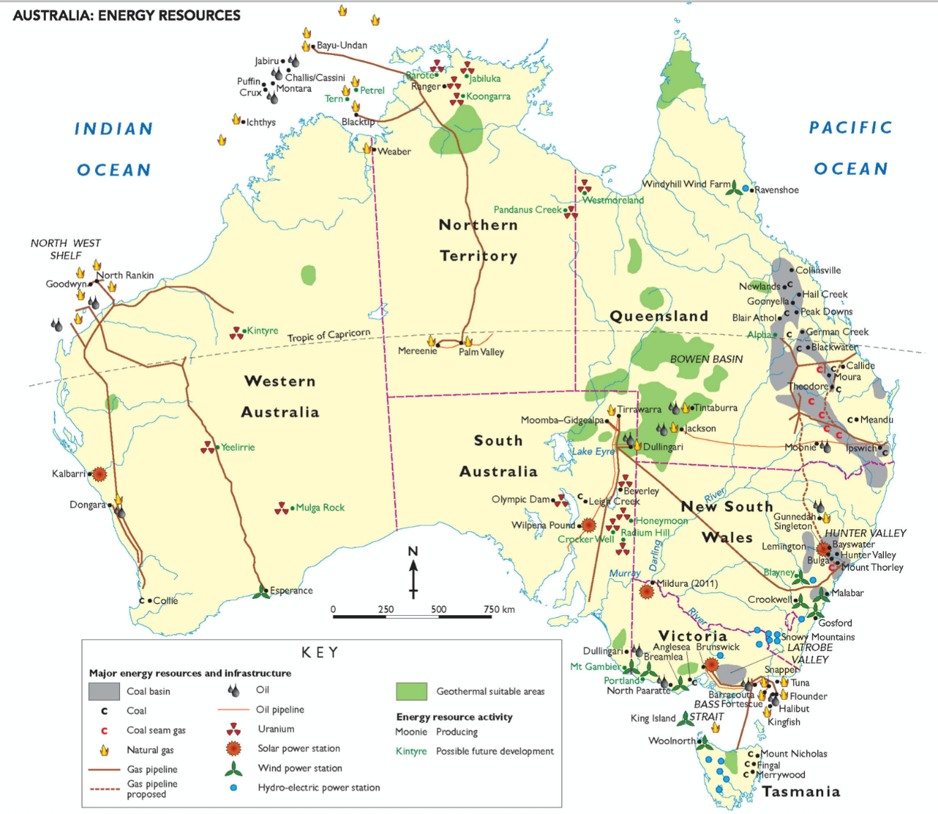

Vocabulary:
Hydroelectric = power produced by water flowing through a turbine. To create hydroelectricity, a dam must be built across a large river
Basin = a depression in the Earth's surface
Crude oil = oil that has not been refined yet into products like petrol for cars
Deposit = places where there are large concentrations of a resource, e.g. a coal deposit of a uranium deposit
Bauxite = a mineral that is used to make aluminium

Map Task:
Zoom into the map to highlight the following natural resource regions of Australia with your ePen:
- 1) Hunter and La Trobe coal valleys
- 2) North West Shelf gas region
- 3) Snowy Mountains hydroelectric resources
- 4) Bass Strait wind and gas resources
- 5) Coal basins of Queensland
- 6) Hydroelectric resources of Tasmania

- Discover- Australia's resources
Australia has more natural resources per head of population than any other country in the world. The main reason for this is that we have a small population in a very large country.

Minerals
Australia is rich in mineral resources. The Pilbara region in Western Australia, for example, has some of the largest reserves of iron ore in the world. Australia also produces many other minerals, including silver, copper, nickel and tin.
Australia is the world’s:
• largest exporter of iron ore, bauxite, lead, diamonds, zinc ores and mineral sands
• second-largest exporter of alumina (processed from bauxite and then turned into aluminium)
• third-largest exporter of gold.

Soils
Australia has generally poor soils, especially when compared with those found in other continents such as North America and Europe. Most Australian soils are low in nutrients, and in some parts of the continent, particularly the more arid areas, high salt content is also a problem. Most parts of Australia are suitable only for sheep and cattle grazing, rather than intensive agriculture, owing to low rainfall and poor soils.
There are regions of good soil scattered throughout Australia. These include soils formed from volcanic rock, such as those on the Darling Downs in Queensland and around Orange in New South Wales, and alluvial soils (found in river valleys).

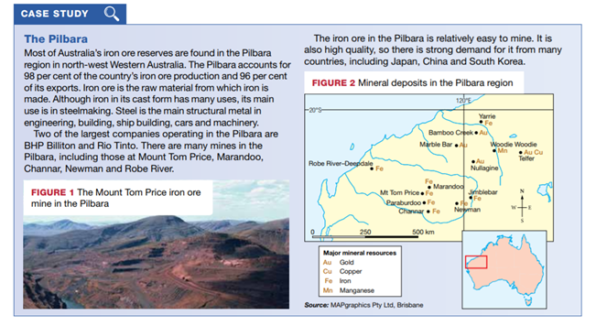

Natural scenery
Australia’s spectacular scenery attracts tourists from all over the world, particularly to those sites that are on the World Heritage List. This means that they are recognised as being of global importance due to their great natural or cultural significance.

Forests
Apart from Antarctica, which has no trees, Australia is the world’s least forested continent. The most common vegetation in Australia is woodland and shrubland. Before European occupation, about nine per cent of Australia was forested. Today, about five per cent of the country is forested. Even though Australia exports timber products, it also imports a lot of timber, particularly softwoods such as pine.

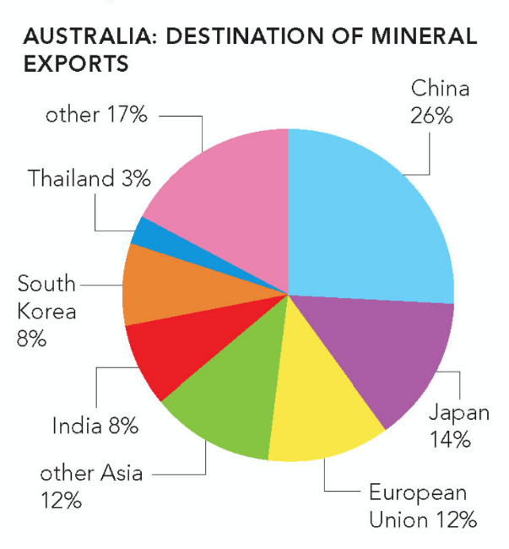

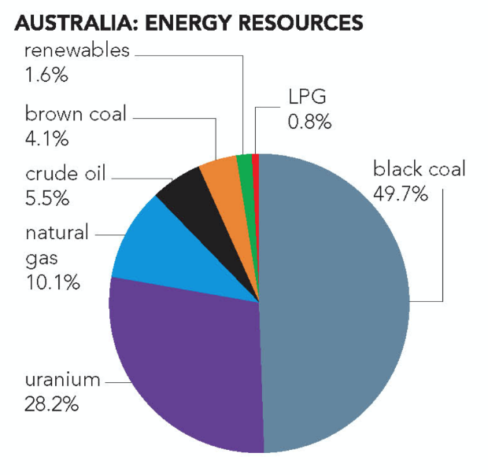

- Apply- Answer the questions below
- List the main mineral resources produced in Australia.

- Refer to the case study of the Pilbara:
- Where does Australia's main iron ore production take place?

- What is the main use of iron ore?

- Why is there strong demand overseas for Australian iron ore?

- Why are many Australian soils suitable only for grazing?

- To which region of the world do most of Australia's resources go?

- What type of energy resources is most abundant in Australia?

- How does mining affect the environment. Create a flow chart, or fill in the template below (NB: use your ePen for this task. Alternatively this will need to be saved and opened in a new program)

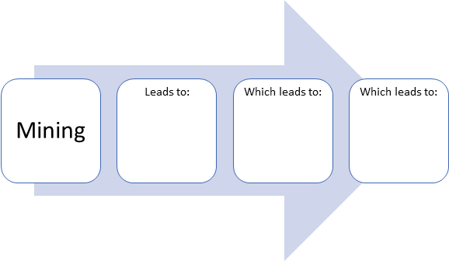

- Review and Reflect
In pairs quiz each other on the following questions (answer below - you'll have to scroll a bit - no peeking!)
- Where in Australia are Australia's major energy resource regions and what is produced in each region?
- What resources does Australia export to the rest of the world?
- Who are the main buyers of Australian resource exports?
- What are the definitions of:
  - Hydroelectric
  - Crude oil
  - Basin
  - Deposit
  - Bauxite

Do you think Australia can rely on only the resources it has or Do you think we need help from other countries? Why?

Review answers
- Coal - La Trobe Valley in Victoria; Hunter Valley in NSW; several major coal deposits in Queensland
  - Gas - North West Shelf; Bass Strait; Timor Sea
  - Hydroelectricity - Snowy Mountains; Western Tasmania
  - Uranium - eastern parts of South Australia; far-north Northern Territory e.g. Jabiluka
  - Wind - southern Victoria; Bass Strait; eastern parts of NSW
- Iron Ore, Bauxite, Coal, Gold, Zinc, Lead, Diamonds
- China, Japan, EU, India, South Korea, other parts of Asia
- Hydroelectric = power produced by water flowing through a turbine. To create hydroelectricity, a dam must be built across a large river
Basin = a depression in the Earth's surface
Crude oil = oil that has not been refined yet into products like petrol for cars
Deposit = places where there are large concentrations of a resource, e.g. a coal deposit of a uranium deposit
Bauxite = a mineral that is used to make aluminium

1.4 How does water change places?
Wednesday, 30 October 2024
4:12 PM
How Does Water Change Places?

Learning intention | To describe and explain how the movement of water affects the landscape.  To describe and explain river erosion, deposition and meandering.  To understand how river courses change over time, according to modern science.  To understand how river courses change over time according to indigenous cultures.
Success criteria | I can define and explain erosion, deposition and meandering.  I can explain how moving water can change a landscape.  I can create a flow diagram based on the creation of the Grand Canyon  I can annotate a geographical image

  - ENGAGE: Aboriginal and Torres Strait Islander Perspective on forming rivers and landscapes
Watch the following video, Awakening of the Rainbow Serpent and answer the questions below
(Alternatively watch a reading of one indigenous telling of the Rainbow Serpent story: The Rainbow Serpent | An Aboriginal Dreamtime Legend | Story Time With Ozzie NOTE: Watch from 30 seconds to 2mins AND 6:50-8:15. Will need new questions. CER 2025)

Awakening Of The Rainbow Serpent (6mins)
WARNING:
  - Framed generically for audiences beyond Australia.
  - AI-generated images.


What did the Earth look like before the Rainbow Serpent changed everything?

Explain how the Rainbow Serpent formed rivers

Explain how the Rainbow Serpent formed hills and mountains

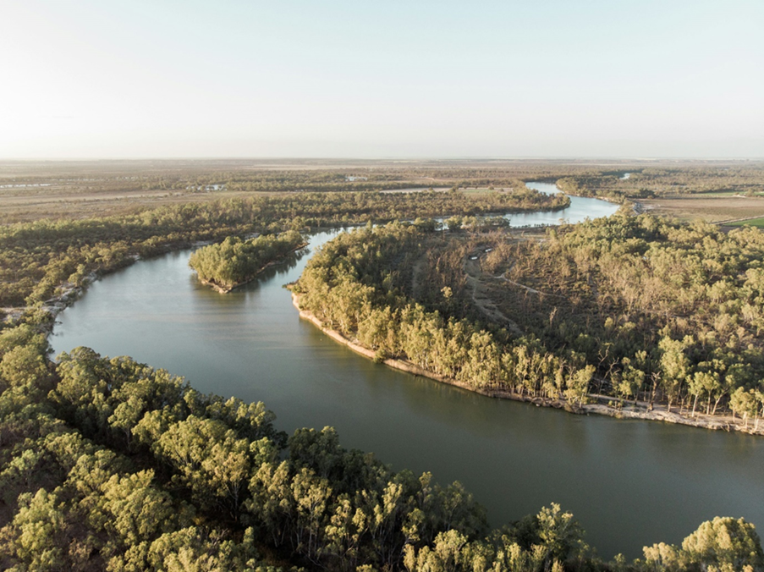

Study the image above of the Murray River, and explain how the river may have been formed according to the Dreamtime perspective of the Rainbow Serpent. Write your answer below.

Remember, this is only one perspective on the formation of waterways.

Vocabulary – In this topic you will need to understand relevant terms.
Provide a definition of each of the following, with reference to a river.
  - Meander -

  - Erode or Erosion -

  - Sediment -

  - Water Flow -

  - Barren -

Now use each of these terms in a separate sentence to show your understanding

  - DISCOVER: How Rivers Change Their Course Over Time
Rivers don’t always stay in the same place; they can change their path over time. This happens because of natural processes like erosion and deposition, and sometimes because of human activity or changes in the climate. Here’s how it works:
1. Erosion and Deposition

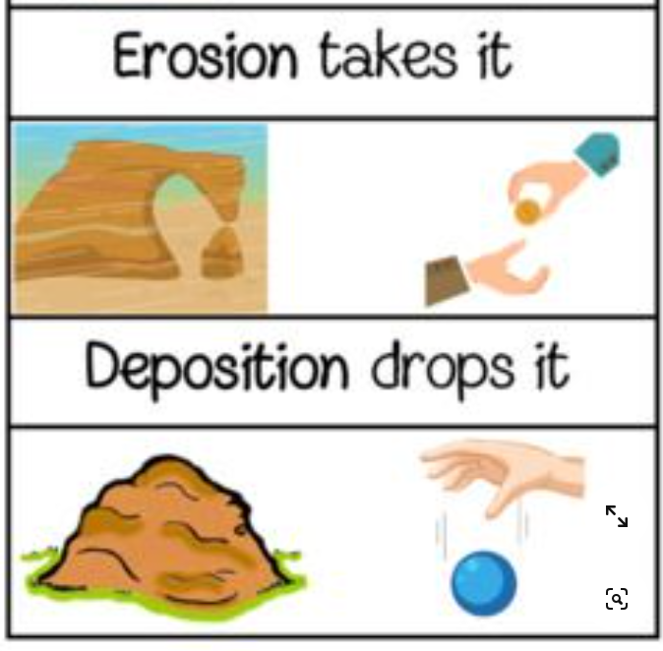
As rivers flow, they carry away dirt, rocks, and sand from one place to another. This is called erosion. On the outside of a river bend, where the water flows fast, the river erodes the land. On the inside of a bend, where the water moves slower, the river drops off the dirt and sand it’s carrying. This process builds up new land, creating point bars on the inside of bends, while the outside of bends keeps getting eroded and the river curves more. Over time, this creates winding curves called meanders.
2. Meandering

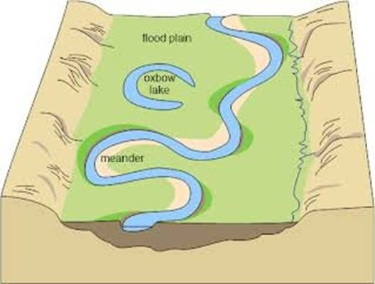
Rivers often end up winding back and forth across the land. The more the river curves, the more erosion happens on the outside of the bends, and more sand and dirt build up on the inside of the bends. This makes the river bend even more. As time passes, these bends can get bigger and bigger.
3. Oxbow Lakes
Sometimes, a river’s curve can get so big that it forms a narrow strip of land, and during a flood or strong current, the river might break through this narrow part and find a quicker, shorter path. When this happens, the old bend is left behind and can form a shape like a horseshoe, called an oxbow lake.
4. Flooding
Floods can also change the river's path. When rivers overflow, they can carve new channels, move dirt and rocks, or even create new paths. Floods are one of the fastest ways rivers can change where they go.

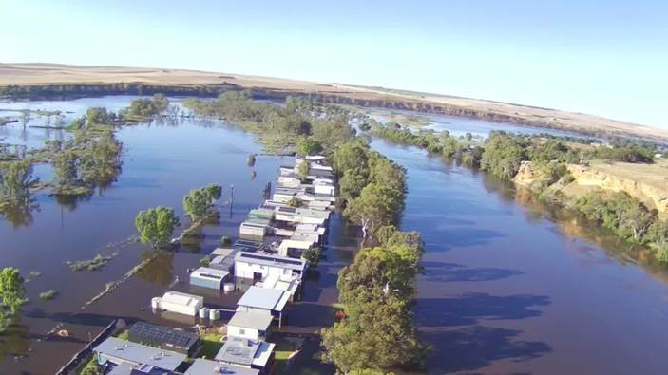

5. Human Influence
People can also change rivers. Things like dams, roads, and buildings can block or change the river’s path. When humans do this, it can make rivers change direction more quickly or in ways that wouldn’t happen naturally.

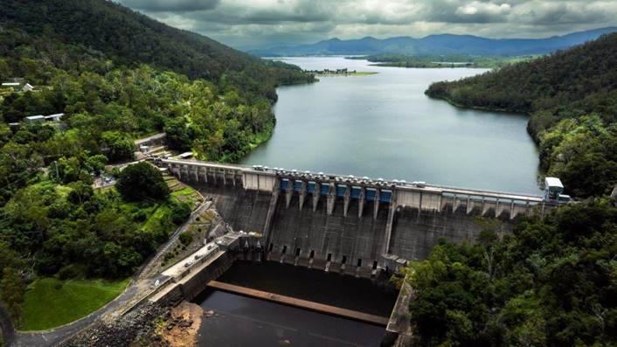

6. Climate Change
Changes in weather, like more rain or longer droughts, can affect how rivers move. More rain can cause floods, which can change the river’s path. Less rain might make the river flow more slowly and change less often.

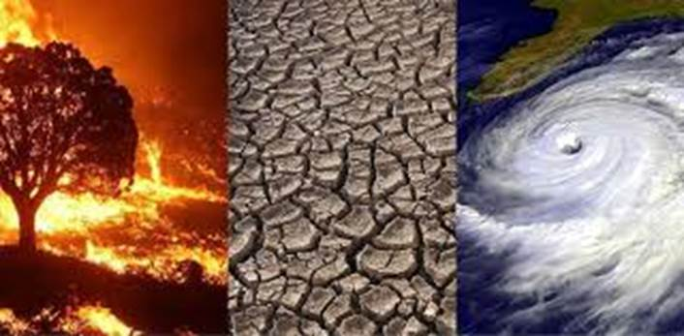

In Summary:
Rivers change their course over time because of erosion, where they wear down the land and move dirt and rocks around. This makes rivers bend, create oxbow lakes, and sometimes change their path after floods. Humans and changes in the weather can also speed up or affect these changes.

Watch the following video and answer the questions below:
Why Do Rivers Curve?

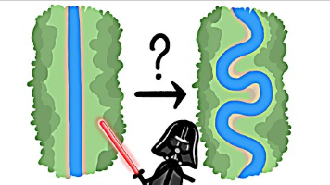

Video Questions:
  - In your own words, explain how a muskrat might contribute to changing the direction of a river.

  - Explain how deeper curves occur within a flowing river.

  - How does an ox-bow lake or billabong form?

  - APPLY: Mini Case Study - The Grand Canyon
How Was the Grand Canyon Formed? (4.28mins)
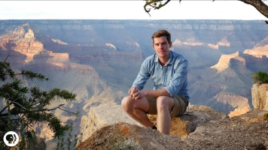

After you watch the video, create an 8 step Flow Diagram to show how the Grand Canyon was formed.

Teacher note: students should include the following:

  - Mazatzal Mountains
  - Erosion of these mountains
  - Ancient oceans, deposition and layering
  - Tectonic uplift creates Rocky Mountains
  - Colorado River created by snowmelt
  - Descending river water, 0.5 million tonnes of transported material daily
  - Erosion by the Colorado River
  - Ice, rain and snow erosion of the canyon walls.

Use this table or the Word doc below
Step 1 | Billions of years ago the Mazatzal Mountains existed where the grand canyon is today.
Step 2 | The mountains were eroded down to only tens of metres high (over millions of years)
Step 3 | Ancients oceans rose and fell over the same area, depositing layers of sand, rocks and shells. (layer cake ready to cut)
Step 4 | Tectonic plates pushed up the area into a plateau and also formed the Rocky Mountains.
Step 5 | The Colorado River was formed by ice melting off the Rocky Mountains
Step 6 | Descending river water carries 0.5 million tonnes of sediment daily,
Step 7 | The river erodes the banks.
Step 8 | Ice, rain and snow continue to erode the canyon walls.

<<Grand_Canyon_Formation_Worksheet.docx>>

Annotate the image below of a section of the Grand Canyon, including the Colorado River. Be sure to indicate the following:
  - Erosion
  - Layering or stratification
  - Deposition
  - Meandering

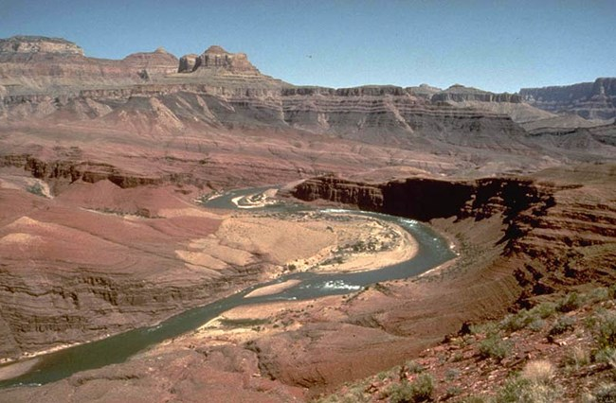

Self-Assessment
Monday, 18 March 2024
3:48 PM

Student Assessment

 | Level 6 | Level 7 | Level 8 | Level 9 | Level 10 | Level 11
1.1 Characteristics of place | I can identify diverse characteristics of places. | I can explain diverse characteristics of places. | I can explain processes that influence characteristics of places. | I can predict changes in the characteristics of places over time. | I can identify the implications of change for the future. | I can synthesise multiple data sources to provide analysis about the predicted changes.
2.1 Map and Data Analyses | I can identify the key features of a map (BOLTSS). | I can use geographical language to interpret increases, decreases or trends in maps, graphs, charts, or tables. | I can describe patterns, quantify them, and point out exceptions in maps, graphs, charts, or tables. | I can use social, historical, environmental, economic, political or technological factors (SHEEPT) to explain trends in maps, graphs, charts, or tables. | I can analyse relationships between multiple sources of geographical data. | I can analyse and draw reasoned conclusions from independently collected sources of geographical data.

Teacher Assessment

 | Level 6 | Level 7 | Level 8 | Level 9 | Level 10 | Level 11
1.1 Characteristics of place | I can identify diverse characteristics of places. | I can explain diverse characteristics of places. | I can explain processes that influence characteristics of places. | I can predict changes in the characteristics of places over time. | I can identify the implications of change for the future. | I can synthesise multiple data sources to provide analysis about the predicted changes.
2.1 Map and Data Analyses | I can identify the key features of a map (BOLTSS). | I can use geographical language to interpret increases, decreases or trends in maps, graphs, charts, or tables. | I can describe patterns, quantify them, and point out exceptions in maps, graphs, charts, or tables. | I can use social, historical, environmental, economic, political or technological factors (SHEEPT) to explain trends in maps, graphs, charts, or tables. | I can analyse relationships between multiple sources of geographical data. | I can analyse and draw reasoned conclusions from independently collected sources of geographical data.

Topic 2 - Water Uses as a Resource
Saturday, 16 June 2018
12:01 PM

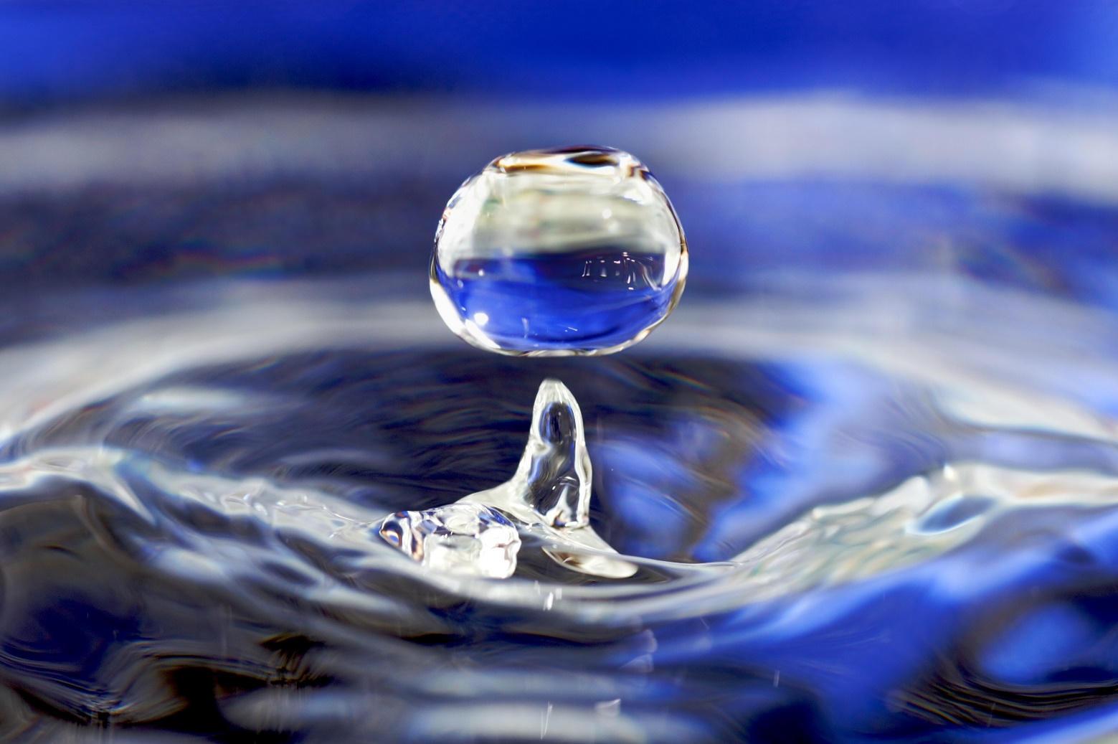

The amount of water on Earth has not changed since the beginning of time; there is only a finite, or fixed, amount. The water used by ancient and extinct animals and plants millions of years ago is the same water that today falls as rain. The amount of water cannot be increased or decreased. It is cycled and recycled, and constantly changes its state from gas, to liquid, to solid, and back.

Water is a resource. Like any other resource, it has no value in itself, but has great value when a use is found for it. Environments where water is found are also a resource. A river can be the site of a settlement that provides transport as well as food. A riverine environment that includes fish, birds, wildlife, wetlands, plants and micro-organisms is also valuable as a living system and can therefore be regarded as a resource.

JacPlus Textbook Reading
  - Chapter 2.7 - Is water a renewable resource?
  - Chapter 2.9 - How is groundwater used as a resource?

2.1 Water Uses
Monday, 16 July 2018
8:07 PM
Learning intention | To describe the multiple and competing uses of water  To learn water-saving tips for home water use
Success criteria | I can identify and describe the stages of the water cycle  I can explain and describe the uses of water  I have analysed and discussed ways of saving water around the home
Vocabulary | Irrigation: Widespread watering of farmland
Content for Self-Assessment | Map and Data Analysis  Interconnection

Lesson Focus: How do humans use water?

  - Engage

List 5 ways that you use water on a daily basis?

  - Discover - Interconnection

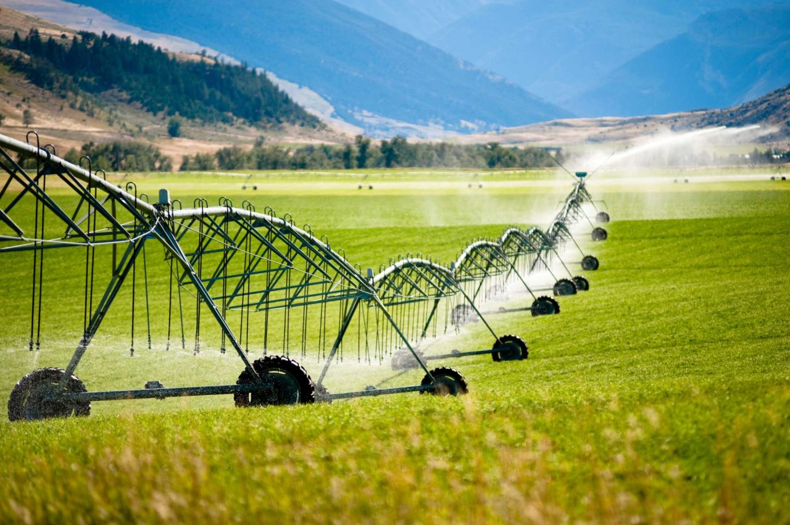

Since the beginning of human history, we have relied on water. We drink it in order to survive. We wash, cook and clean with it and we use it to grow our food and produce electricity. In this way, water is arguably our most precious resource. Life on Earth without it would be impossible. One of the challenges facing Australia today is that we use too much of this environmental resource.

Match the water use to its explanation:

Suggestion: Print this table out and cut it up. Give half the class a term and the other half a definition. Students then need to find their partner. Once they have done that, they need to sit down with their partner and explain to the rest of the class why they have chosen each other. Then, as a group, write in the correct numbers in the blank column based on the student responses.

ANSWERS
1 | Irrigation of parks, gardens and sporting grounds | 4 | The average Australia household uses over 350 litres of water a day for drinking, preparing food, washing, cleaning, flushing toilets, cleaning cars, and water lawns and gardens. Toilets and bathrooms account for about 40 per cent of this domestic water use.
2 | Environmental needs | 8 | Large rivers (such as the Nile in Egypt, the Rhine in Europe and the Yangtze in China) have been used for centuries for trade, as they provide a fast method of transporting goods between regions and countries.
3 | Irrigation of crops and pastures | 9 | Electricity can be generated from the energy of moving water. Usually, to do this a dam must be constructed across a river and a lake formed behind it. This allows the river's flow to be controlled and released through the dam to produce electricity.
4 | Domestic uses | 1 | Many parks, gardens and sporting grounds, including football ovals, rely heavily on water in order to survive. In dry areas, water is often taken from drinking shortages to keep them green and healthy. This is the number use of water in Australia.
5 | Firefighting | 14 | Commercial and recreational fishing depends on clean oceans, rivers and lakes.
6 | Spiritual uses | 2 | As well as being used for human consumption, fresh water is a vital part of the natural environment. Taking too much water from a river can cause many environmental problems, such as weed growth, fish deaths and salt build-up.
7 | Power generation: coal-fired and nuclear power | 11 | The construction industry relies heavily on water in order to make concrete and many building supplies, such as bricks. Many industrial processes use large quantities of water for cooling and cleaning.
8 | Navigation and trade | 3 | Irrigation accounts for most of the world's water use. In some arid areas, including many parts of Australia, irrigation is use to grow crops. So water provides us with our food as well as our drink.
9 | Power generation: hydroelectric power | 12 | The mining industry relies heavily on water to cool machinery, enable drilling and process minerals and iron ore taken from the ground.
10 | Snow-making | 13 | Recreational activities (such as water-skiing and swimming) generally have little impact on the quantity and quality of fresh water. Pollutants in the water from industry upstream can affect water quality and make the water unsuitable for recreation.
11 | Construction and industry | 7 | Virtually all power stations use large quantities of water. Coal-fired power stations heat water to produce steam that turns turbines to create electricity. Water is also used to cool the station. Nuclear power plants operate in much the same way.
12 | Mining | 5 | Firefighters around the world rely heavily on a constant supply of water in order to carry out their work.
13 | Recreational activities | 10 | Artificial snow-making is important in countries such as Australia where natural snowfalls can be infrequent. However, many countries with more regular snowfalls now also use snow-making machines in order to improve conditions and attract more tourists.
14 | Fishing | 6 | Water holds a special significance for almost all world religions. It often plays a key part in religious ceremonies.

  - Apply:

  - What activity uses the most water in Australia? How much of our water does it use?
  - How can water be used to help create electricity?
  - Identify two water uses that might impact one another.

  - Review and Reflect – Map and Data Analysis

Water usage worksheet (PRINTor use the table below)
<<Water Usage Worksheet.pdf>>

Using this Table as a guide complete the water use handout and see how much water your household uses every week

Washing hands | 2.5 litres per wash
Showering | 15 litres per minute
Brushing Teeth | 15 litres water running/ 1 litre no running water
Drinking Water | 3-4 litres of water per day
Toilet Use | 3 litres per half flush/ 4.5 per full flush
Washing Machine Use | 60 litres Front Loader / 80 litres Top Loader per wash
Dishwasher Use | 13-18 litres per wash
Handwashing Dishes | 4-6 litres per minute.
Pool Maintenance/Top Up | 750 litres per week
Leaking Taps | 200 Litres per week, per tap.
<<Water use chart.pdf>>

HOW DO YOU USE WATER AT HOME?
Name: ___________________________ Date: ___________________________

WATER USAGE | YOUR ANSWER | TOTAL AMOUNT OF WATER USED PER DAY/WEEK
How many times do you wash your hands per day? | Example:  5x2.5=12.5 | 12.5 x 7=87.5
How many times do you brush your teeth per day?
How many times do you flush the toilet per day?
How many baths/showers do you take a day?
How often do your parents use the washing machine in a week?
How many dishwasher loads do you run per week?
How many times do you wash the dishes by hand per week?
Do you have a pool at home?
Do you have any leaking taps at home?

2.2 The World's Water
Monday, 16 July 2018
9:01 AM

Lesson focus: Where is the world's water?

Learning intention | To describe and analyse water as a limited and essential resource
Success criteria | I can identify the features of water as a limited resource  I can compare the uses for water between countries  I can analyse patterns on a map
Content for Self-Assessment | Map and Data Analysis

For this lesson, you will be introduced to facts about the world’s water through the studying and analysis of various infographics.

  - Engage: Watch
Water Crisis - A short introduction

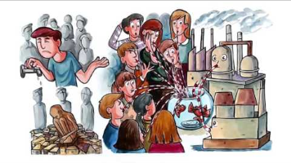

  - Develop and Discover: Map and Data Analysis

Infographics:

Study the below infographics and using the information provided and your own knowledge, answer the questions below.

Figure 1.

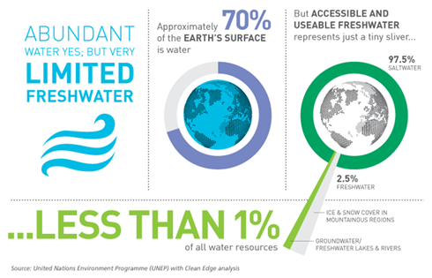

Figure 2.
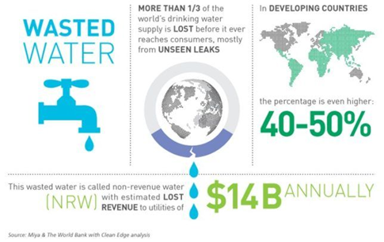

Figure 3.
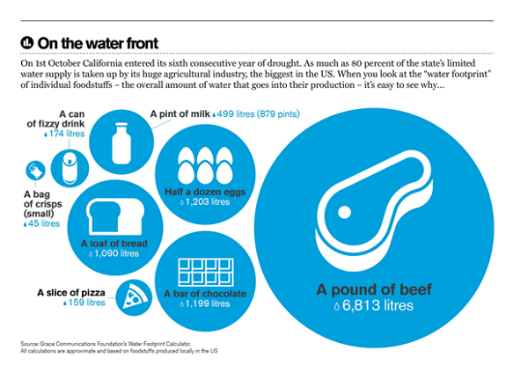

Answer

  - What percent of the Earth's water is fresh?
  - How much water is found in rivers, lakes, wetlands, and ground water?
  - Why do some places have more water than other places?
  - Explain what makes water accessible and useable with reference to some of the barriers to water being accessible and useable.

  - Apply: Map and Data Analysis - PQE Analysis (Pattern Quantification Exception)

Map analysis- Figure 1.
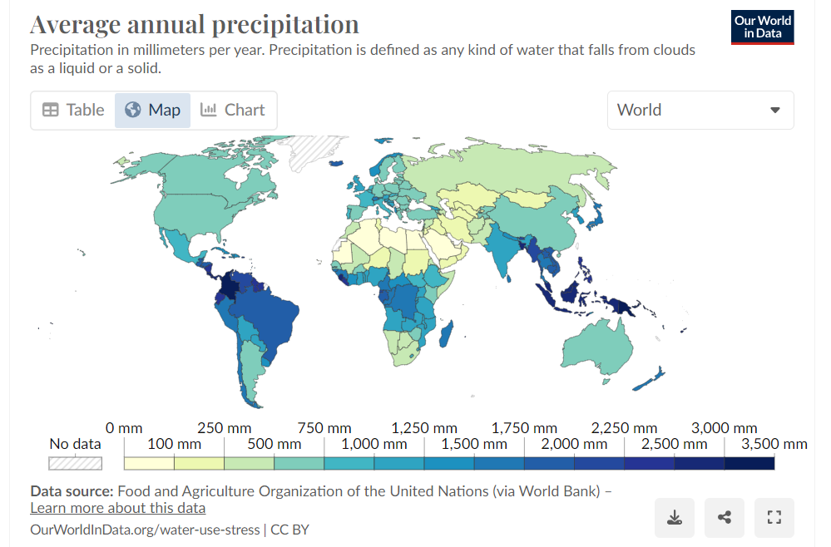

In figure 1, describe how much rainfall there is in North Africa and the Middle East

In figure 1, which countries are affected by the tropical rainfall

Write a PQE paragraph based on Figure 1 map
P-
Q-
E-

Review and Reflect

Step 1. Each student will receive a country
Step 2. Find the rainfall for your country on the map above
Step 3. Organise yourselves in order of highest rainfall to lowest.
Step 4. Once students are in order, quiz them at random.
For example:
– “What’s the rainfall like in your country?”
– “Is your country wet or dry? Why do you think that is?”
– “Compare your country’s rainfall to someone else's.”
– “How close to the equator is your country? Does that affect its rainfall?”

Review
Kahoot about water scarcity: https://create.kahoot.it/details/86dad7f5-d5c2-423b-bf77-8eccab16641b?drawer=
Extension question: Why might a particular group of people be disadvantaged by water scarcity?

  - Review and Reflect

Why are there so many 'unseen leaks' for freshwater in Developing countries?

2.3 The Significance of Water
Monday, 4 July 2022
5:39 PM
Lesson Focus: The Value and Significance of Water

Learning intention | To describe the significance and value of water on the First Nations People of Australia
Success criteria | I can identify and explain the uses of water in Aboriginal communities.  I can explain the spiritual perspective of water sources of Aboriginal people.  I can discuss the potential solutions to balance consumption and sustainability of water sources.
Content for Self-Assessment | Interconnection

- Engage: Watch and Answer
That's My Water! NT: Water in traditional culture

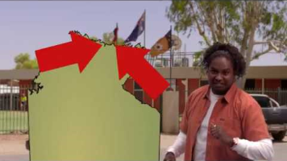
- The video mentions that water is 'precious' for many reasons, identify what these reasons were.

- According to the video, identify the dreamtime stories that are told about water.
- Identify three new things you learnt from the video and share them with the class.

- Discover and Develop
Complete the table below about the different values of water to First Nations Peoples. An example has been done for you

Value Type | Meaning | Example
Aesthetic value | attractiveness of a landscape or landform | The beauty of the beach
Economic value
Cultural value
Spiritual value
<<Sample responses Task 1 and 2, Lesson 2.3.docx>>

Case study: Custodians of the River
<<Custodians of the River.pdf>>

- Apply

In groups of three, each read and take notes from one of the sections of The Guardian article, ‘Fitzroy River: the push to prevent a repeat of the Murray-Darling Basin disaster’.
Linked here: https://www.theguardian.com/australia-news/2020/sep/06/fitzroy-river-the-push-to-prevent-a-repeat-of-the-murray-darling-basin-disaster

Choose one from the following 3 sections:
- Section 1: Read from the start up to the subheading ‘It has a right to life’ (588 words, 4-minute read).
- Section 2: Read from ‘It has a right to life’ to the subheading ‘The Martuwarra Fitzroy River Council’ (736 words, 5-minute read), including video (01:43).
- Section 3: Read from the subheading ‘The Martuwarra Fitzroy River Council’ (588 words, 4-minute read), including video (01:40).
Write down key information as you read and report back to the group to share your notes.
Use the template to guide your notes
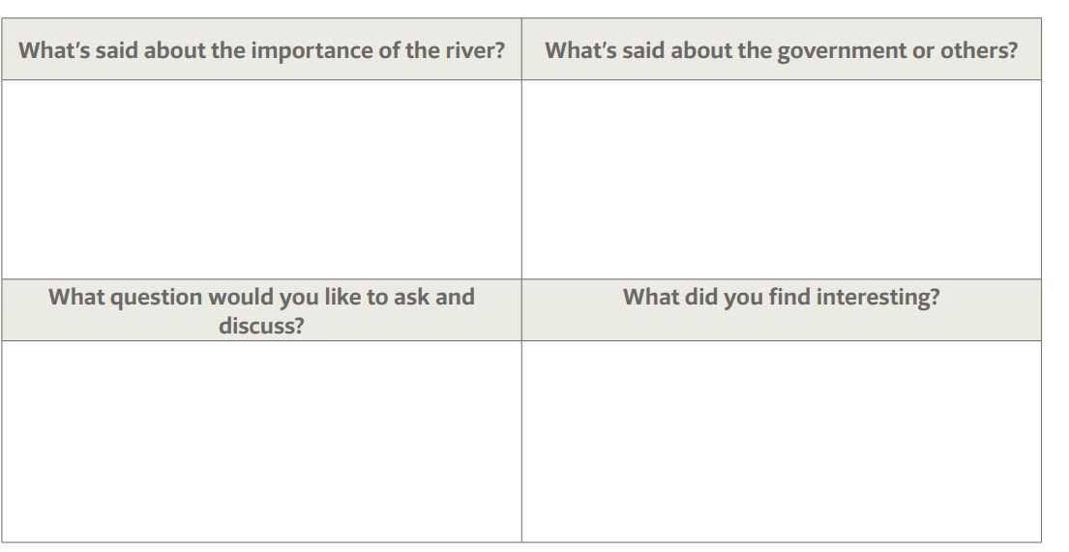

- Review and Reflect
Write a TEEL paragraph that identifies a significant water value for First Nations people and explain its importance.

Further teacher reading:
Case study: In what ways is water important to First Nations Peoples in Australia?
Y7_Geography_Values-of-water_AC9HG7K01_K02_K03_AC9HG7S01_S04_Student-Handouts.pdf

<<Fitzroy MODEL RESPONSES model responses Importance of river and Stakeholder commentary.docx>>

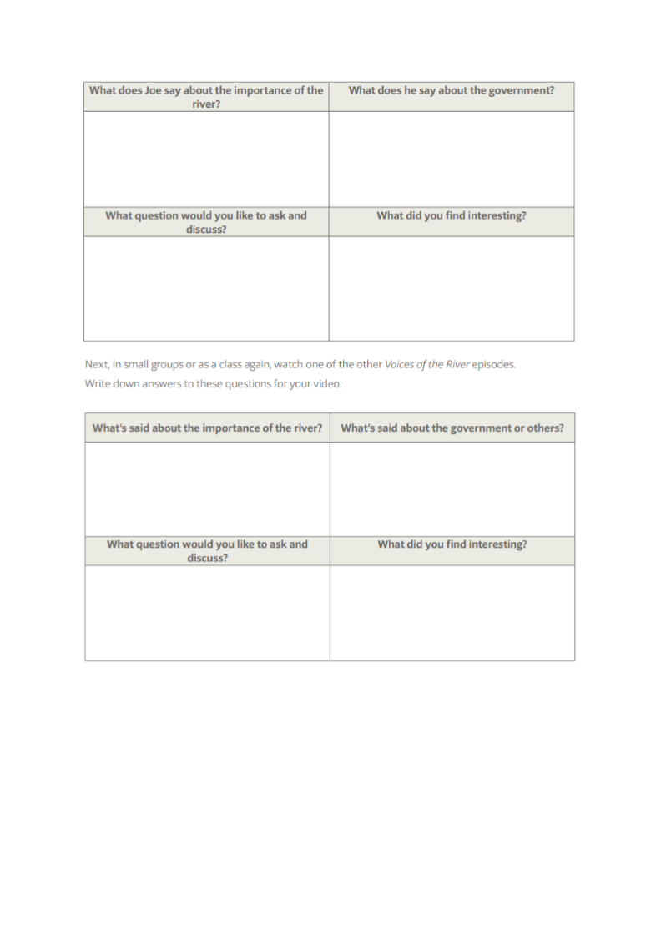

Why is it important to understand the spiritual perspective of water sources of the Aboriginal people in these communities?

  - Review and Reflect - Interconnection

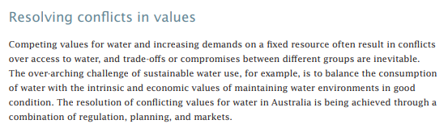

In pairs or small groups, discuss some potential solutions to resolving conflicting values of water?

Self Assessment
Monday, 18 March 2024
3:46 PM

Student Assessment
 | Level 6 | Level 7 | Level 8 | Level 9 | Level 10 | Level 11
1.2 Interconnection | I can identify how places, people, and environments are connected. | I can identify interconnections within and between places, people, and environments. | I can describe interconnections within and between places, people, and environments. | I can explain interconnections within and between places, people, and environments over time and at different scales. | I can analyse interconnections within and between places, people and environments over time and at different scales. | I can synthesise multiple data sources to analyse interconnections within and between places, people and environments.
2.1 Map and Data Analyses | I can identify the key features of a map (BOLTSS). | I can use geographical language to interpret increases, decreases or trends in maps, graphs, charts, or tables. | I can describe patterns, quantify them, and point out exceptions in maps, graphs, charts, or tables. | I can use social, historical, environmental, economic, political or technological factors (SHEEPT) to explain trends in maps, graphs, charts, or tables. | I can analyse relationships between multiple sources of geographical data. | I can analyse and draw reasoned conclusions from independently collected sources of geographical data.

Teacher Assessment
 | Level 6 | Level 7 | Level 8 | Level 9 | Level 10 | Level 11
1.2 Interconnection | I can identify how places, people, and environments are connected. | I can identify interconnections within and between places, people, and environments. | I can describe interconnections within and between places, people, and environments. | I can explain interconnections within and between places, people, and environments over time and at different scales. | I can analyse interconnections within and between places, people and environments over time and at different scales. | I can synthesise multiple data sources to analyse interconnections within and between places, people and environments.
2.1 Map and Data Analyses | I can identify the key features of a map (BOLTSS). | I can use geographical language to interpret increases, decreases or trends in maps, graphs, charts, or tables. | I can describe patterns, quantify them, and point out exceptions in maps, graphs, charts, or tables. | I can use social, historical, environmental, economic, political or technological factors (SHEEPT) to explain trends in maps, graphs, charts, or tables. | I can analyse relationships between multiple sources of geographical data. | I can analyse and draw reasoned conclusions from independently collected sources of geographical data.

Topic 3 - Water Related Hazards and Disasters
Monday, 16 July 2018
8:07 PM

3.1 Hazards & Disasters
Tuesday, 11 September 2018
00:24

Learning intention | To understand hazards, disasters, and strategies to respond to them.
Success criteria | I can identify and explain the difference between natural hazard and natural disaster.  I can describe the different types of hazards.  I can identify and analyse the effect these hazards have on people.  I can explain strategies to respond to hazards and disasters.
Content for self-assessment | Interconnections & Challenges

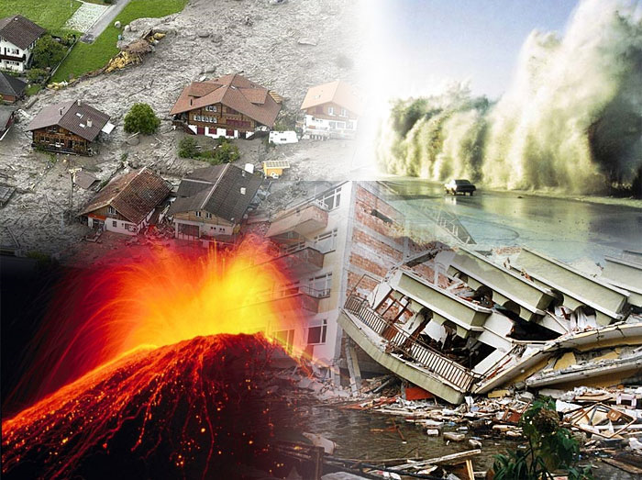

- Engage

Types of Hazards

<<Hazards and Disasters.pptx>>

- Discover

Apply your knowledge

What are the three factors that impact weather conditions?
Air movement, air temperature and the amount of water in the air

What is the difference between weather and climate?

Define:
Natural Hazard
A hazard that has the POTENTIAL to cause harm due to natural processes

Natural Disaster

What is the difference between a disaster and a hazard?

Define and give an example of:
An atmospheric natural hazard

A hydrological hazard

A geological hazard

A biological hazard

- Apply - Strategies to Respond to Geographical Challenges

Today you will research several different hazards and complete your data table. As part of your research you will include the following

- Explain what it is.
- How does it form?
- What can be the impact of your hazard?
- How should people prepare for your hazard?
- How do people respond?
- Recent example from Australia or overseas

Research Table

Topic | What is it? | How does it form? | What is the impact? | How do people prepare? | How do people respond? | Recent example from Australia or Overseas
Thunderstorm | Involves a rain-bearing cloud that interacts with the ground to generate lightning | When warm moist air rises rapidly into the atmosphere, cools, condenses and causes cumulo nimbus clouds. | Cause power outages, damage to property and infrastructure. Can cause bushfires. | Secure loose items  Move vehicles to safe places  Move livestock | For example emergency services remove dangers such as fallen trees
Hailstorm
Cyclone
Typhoon
Tornado

- Review and Reflect - Geographical Challenges

Watch

The Chernobyl Disaster: How It Happened

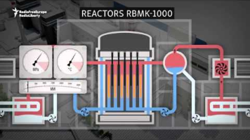

As a class , Discuss the what type of Hazard and Disaster the Chernobyl Plant was.

3.2 Droughts and Floods
Tuesday, 11 September 2018
00:23
Lesson Focus: Understand the why droughts and floods occur and the impact that they have on our world.

Learning intention | To understand the cause and impact of weather events that lead to floods and droughts in Australia and around the world.
Success criteria | I can identify and explain the features and types of droughts and floods  I can describe the impact droughts and floods have on people and the environment  I can create my own learning resource that can test my knowledge of droughts and floods
Content for Self-Assessment | Interconnections & Challenges

Engage

Watch

El Nino and La Nina

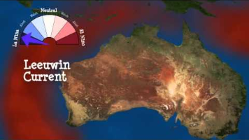

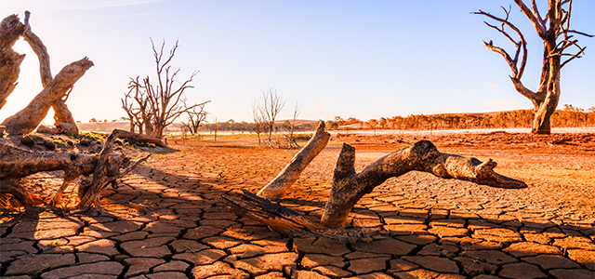
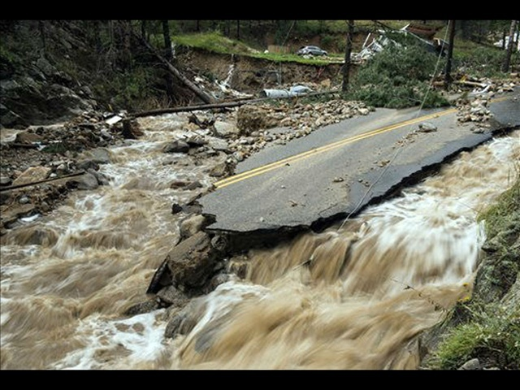

Discover

As a class we will go through this PowerPoint to support your Learning

<<Droughts and Floods.pptx>>

Answer the following Questions

Define drought

Why does Australia experience drought?

Define:
El Niño

La Nina

Southern Oscillation

Explain one impact of a drought - Interconnections between people and environment

Define floods

Identify the different types of floods

Explain one impact of a flood - Interconnections between people and environment

Apply

Create your own Class Trivia!

Using the information above, and your own research, create your own trivia question on the topic of droughts and floods. Each student will be allocated a topic form the list below. You will create one question each.

- El Nino
- La Nina
- Southern Oscillation
- Impacts of droughts
- Impacts of floods

Review and Reflect.

Time permitting, we will play the trivia game as a class

CAT 2024

CAT
AT

<<Water in the World AT.docx>>

<<2024 Year 7 Geography CAT 1.docx>>

A new substitute link for Source 2 Darling Basin

https://theconversation.com/water-theft-laws-and-penalties-in-the-murray-darling-basin-are-a-dogs-breakfast-heres-how-we-can-fix-them-227862

Additional sources Murray Darling
https://www.abc.net.au/btn/classroom/murray-darling-wetlands/12900474 < video embedded

https://www.mdba.gov.au/climate-and-river-health/water-quality-threats/drought

https://www.kidsnews.com.au/environment/bold-plan-to-transport-darling-river-fish-downstream-to-safety/news-story/f110c2af449cea72d47962b78e537892

Murray-Darling Wetlands - Behind the News

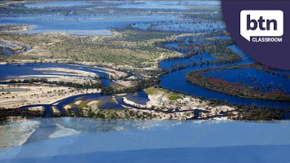

Cape Town

The first article requires a subscription to National Geographic

Alternative articles exploring how Cape Town have managed the crisis more recently:

https://www.washingtonpost.com/world/2024/02/27/south-africa-water-climate-trees/

Aral Sea links:
The Aral Sea Catastrophe Explained

Aral Sea: The sea that dried up in 40 years - BBC News

The Aral Sea Ecological Disaster

Self-Assessment
Monday, 18 March 2024
3:58 PM

Student Assessment

 | Level 6 | Level 7 | Level 8 | Level 9 | Level 10 | Level 11
1.2 Interconnections | I can identify how places, people, and environments are connected. | I can identify interconnections within and between places, people, and environments. | I can describe interconnections within and between places, people, and environments. | I can explain interconnections within and between places, people, and environments over time and at different scales. | I can analyse interconnections within and between places, people and environments over time and at different scales. | I can synthesise multiple data sources to analyse interconnections within and between places, people and environments.
1.3 Challenges | I can identify responses to a geographical challenge. | I can identify and compare strategies to respond to a geographical challenge. | I can compare strategies to respond to a geographical challenge and predict the likely outcomes. | I can evaluate alternative views and strategies to respond to a geographical challenge. | I can evaluate alternative views and responses to a geographical challenge and explain the predicted outcomes. | I can evaluate alternative views and responses to a geographical challenge and draw a conclusion about the most effective response.

Teacher Assessment

 | Level 6 | Level 7 | Level 8 | Level 9 | Level 10 | Level 11
1.2 Interconnections | I can identify how places, people, and environments are connected. | I can identify interconnections within and between places, people, and environments. | I can describe interconnections within and between places, people, and environments. | I can explain interconnections within and between places, people, and environments over time and at different scales. | I can analyse interconnections within and between places, people and environments over time and at different scales. | I can synthesise multiple data sources to analyse interconnections within and between places, people and environments.
1.3 Challenges | I can identify responses to a geographical challenge. | I can identify and compare strategies to respond to a geographical challenge. | I can compare strategies to respond to a geographical challenge and predict the likely outcomes. | I can evaluate alternative views and strategies to respond to a geographical challenge. | I can evaluate alternative views and responses to a geographical challenge and explain the predicted outcomes. | I can evaluate alternative views and responses to a geographical challenge and draw a conclusion about the most effective response.

Additional Resources for 2026
Wednesday, 15 July 2026
2:17 PM

Possible Games that could be worth playing
Friday, 12 December 2025
4:14 PM

- Foodchain - https://lawlesslearning.com/learning-games/foodchain/

This is based off the Murray Darling Basin, but could be interesting if students do their presentation on MDB, this could be a wrap-up activity.

- Drip Trip - Melbourne Water https://www.melbournewater.com.au/drip-trip
Could get one student to control the drip on screen during the 'journey' and then read through each of the facts together as a class

Additional Graphs for Water In Our World
Wednesday, 18 December 2024
10:21 AM
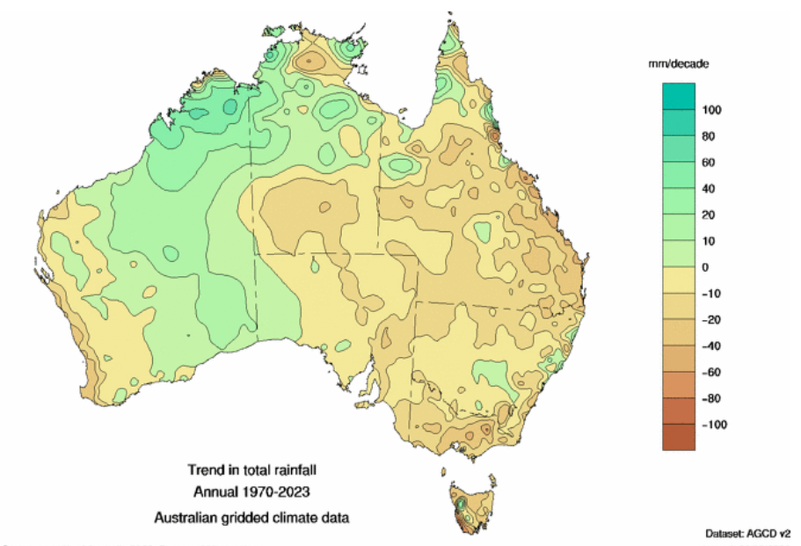

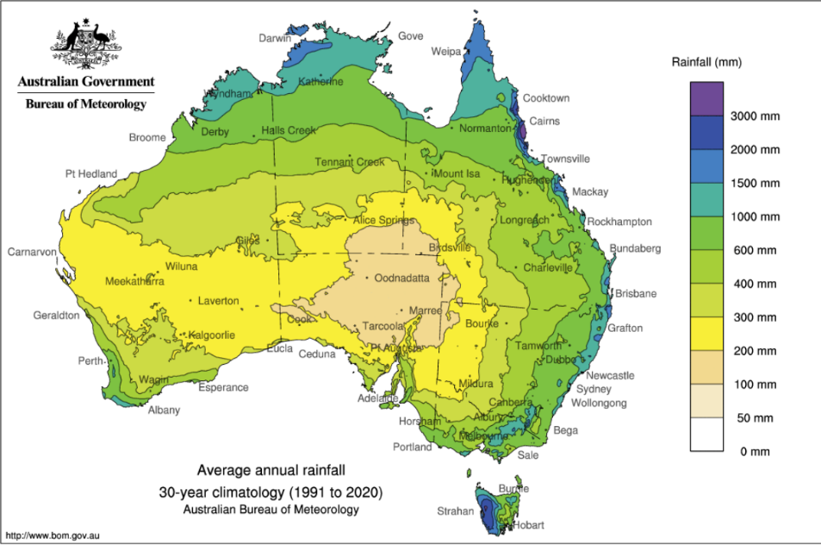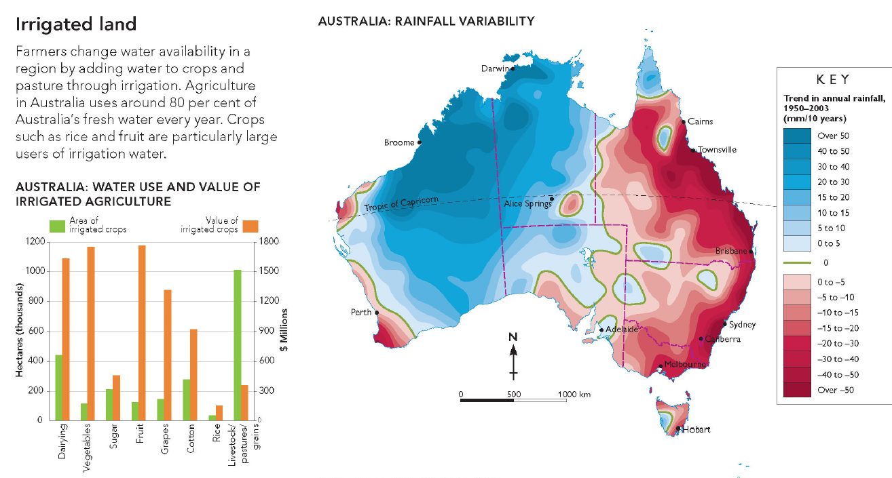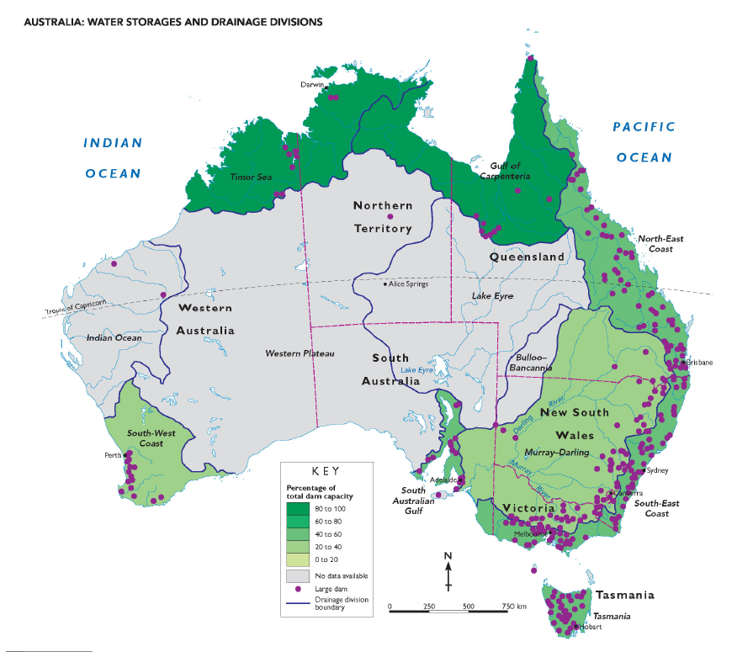

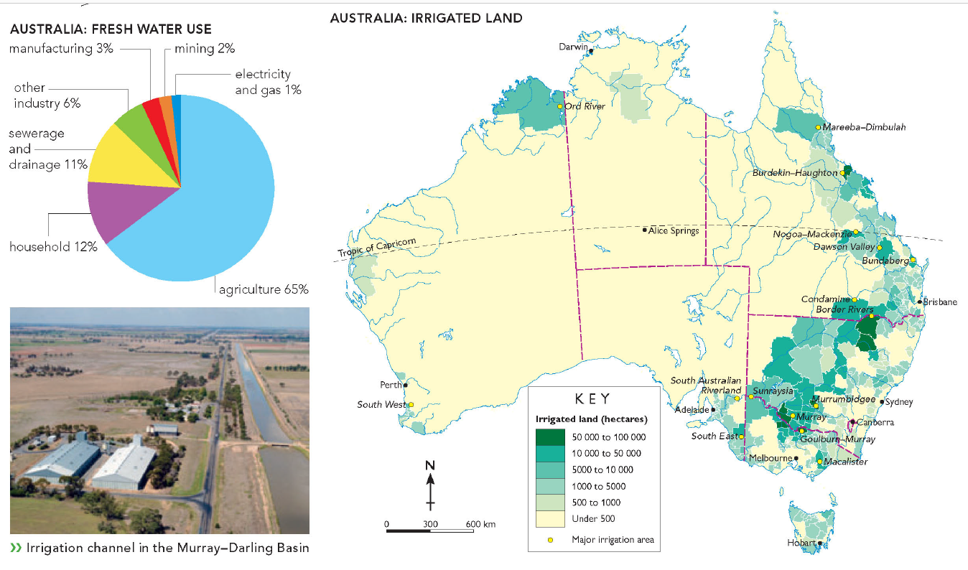

Archive
Friday, 15 December 2023
10:08 AM

1.2 Sustainable use of water

Learning Intention | Explain different types of resources as either renewable or non-renewable  Describe the classification of water resources  Analyse maps and other geographic data to learn more about water resources
Success criteria | I can classify resources as renewable and non-renewable.  I can explain why water is considered a renewable resource.  I can make connections between climate factors (temperature and precipitation), water resource accessibility, and population density.  I can describe patterns, quantify them, and point out exceptions in maps, graphs, charts, or tables.
Content for Self-Assessment | Place and Map & Data Analyses

- Engage: Play Tragedy of the Commons Game https://www.sciencefriday.com/educational-resources/one-for-all-a-natural-resources-game/

Arrange students in a circle, explain the game simulates shared resources, place 30 chips in the centre, read the rules, play music and let students take chips, stop music and double remaining chips (max 30), repeat until pool is depleted or strategies form, discuss outcomes, restart if needed, allow strategy discussion, add new students to simulate growth, continue and observe, finish with a discussion on real-world resource use.

- Discover and Develop

Activity 1 - What is a resource?

Definitions:
Resource
Natural resource
Renewable resource
Non-renewable resource
Recyclable resource

Diagram:



Activity 2 - Water as a resource: How much water is available for use?


Study the diagram above and answer the following questions:
Choose 4 sources of water and describe how they may be used.
Make a prediction about how global warming will affect our use of these sources of water
Discuss why water in glaciers, ice caps and groundwater might be hard to access.

Map Symbols:

Map symbols are icons or graphics located in a key or legend on the side of a map. They represent different features, such as rivers, mountains, roads, and landmarks, making it easier to read and understand the map's information.

Check your understanding:

Why do we use map symbols?

- Apply- Explain Diverse Characteristics of Places.

<<1.2 Sustainable Use of Water.docx>> | Teachers please print in colour and A3

Figure 1. A map portraying the natural resources that each country has.

Using the Map and Legend in figure 1, answer the following questions:

Name three countries that have coal
1.
2.
3.

Name a country that has Minerals but no energy resources

List the energy resources and minerals in Australia
1.
2.
3.
4.
5.
6.
7.
8.
9.

Using your ePen, draw a map symbol of a mineral that is not listed in the legend.

Research and list which countries have that mineral.

- Review- Exit Ticket

In pairs, discuss how we can use more renewable resources in Australia. Share your answers with the rest of class.

Extension - Map and Data Analyses: More detailed maps of Australia's minerals and energy resource.

Have a look at the following two maps and see if you can locate regions of Australia that produce a lot of mineral resources and a lot of energy resources





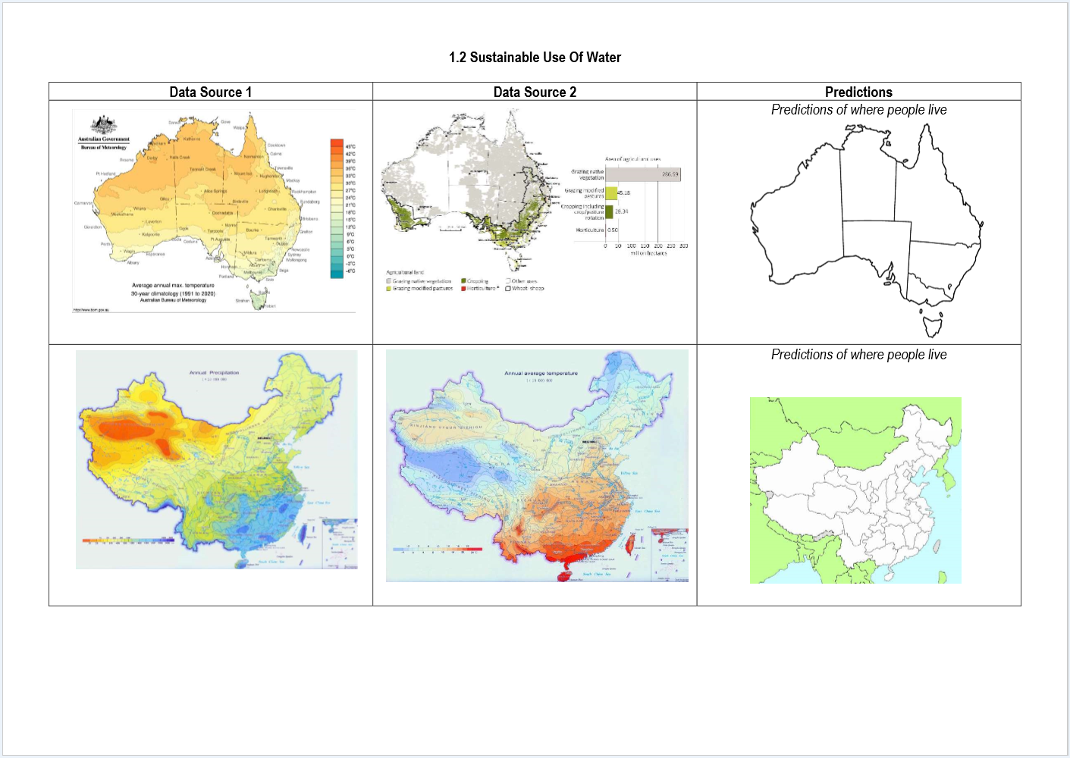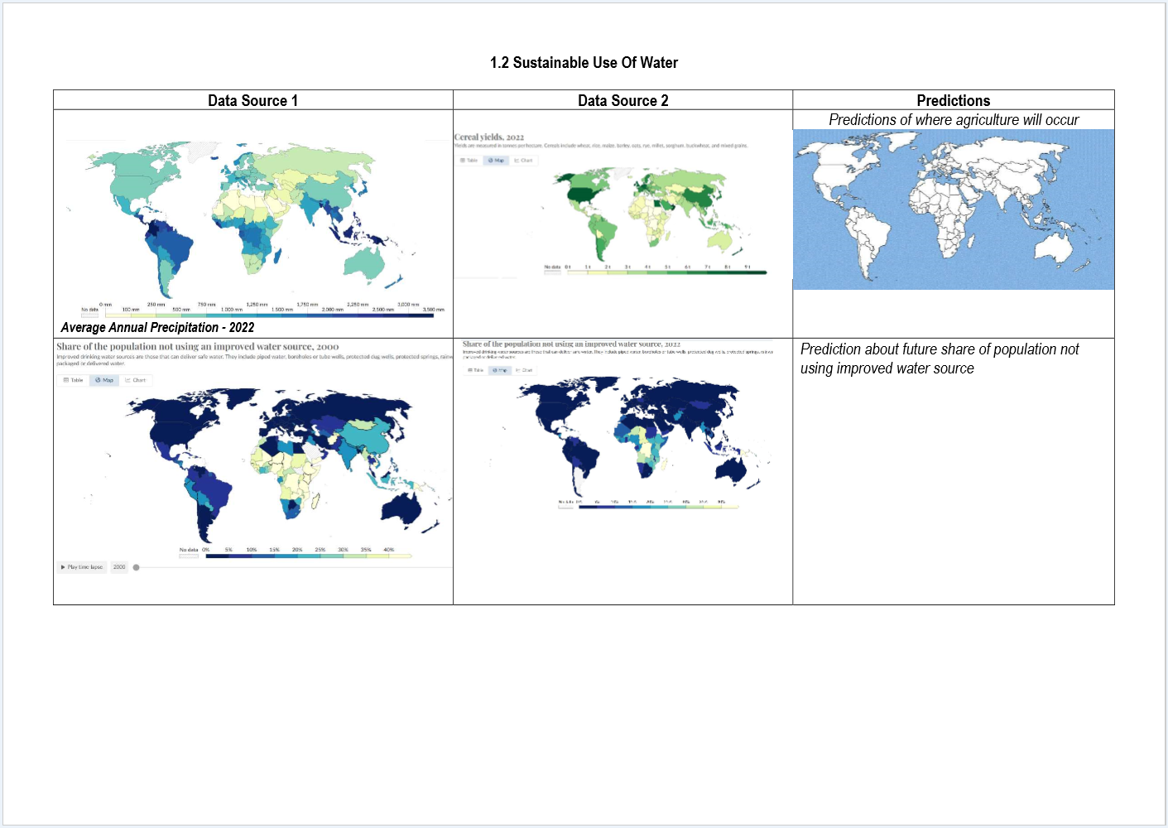

 | Level 6 | Level 7 | Level 8 | Level 9 | Level 10 | Level 11
1.1 Characteristics of place | I can identify diverse characteristics of places. | I can explain diverse characteristics of places. | I can explain processes that influence characteristics of places. | I can predict changes in the characteristics of places over time. | I can identify the implications of change for the future. | I can synthesise multiple data sources to provide analysis about the predicted changes.
2.1 Map and Data Analyses | I can identify the key features of a map (BOLTSS). | I can use geographical language to interpret increases, decreases or trends in maps, graphs, charts, or tables. | I can describe patterns, quantify them, and point out exceptions in maps, graphs, charts, or tables. | I can use social, historical, environmental, economic, political or technological factors (SHEEPT) to explain trends in maps, graphs, charts, or tables. | I can analyse relationships between multiple sources of geographical data. | I can analyse and draw reasoned conclusions from independently collected sources of geographical data.

1.2 Australia's Natural Resources
Saturday, 16 June 2018
12:01 PM
Learning intention | To explain the importance of natural resources to Australia
Success criteria | I can identify major energy resources in regions of Australia  I can explain and describe the use and importance of resources in Australia  I can appraise my knowledge of Australia's resources with a peer or family member
Content for Self-Assessment | Place & Map and Data Analyses

- Engage: Which natural resources are abundant in Australia?

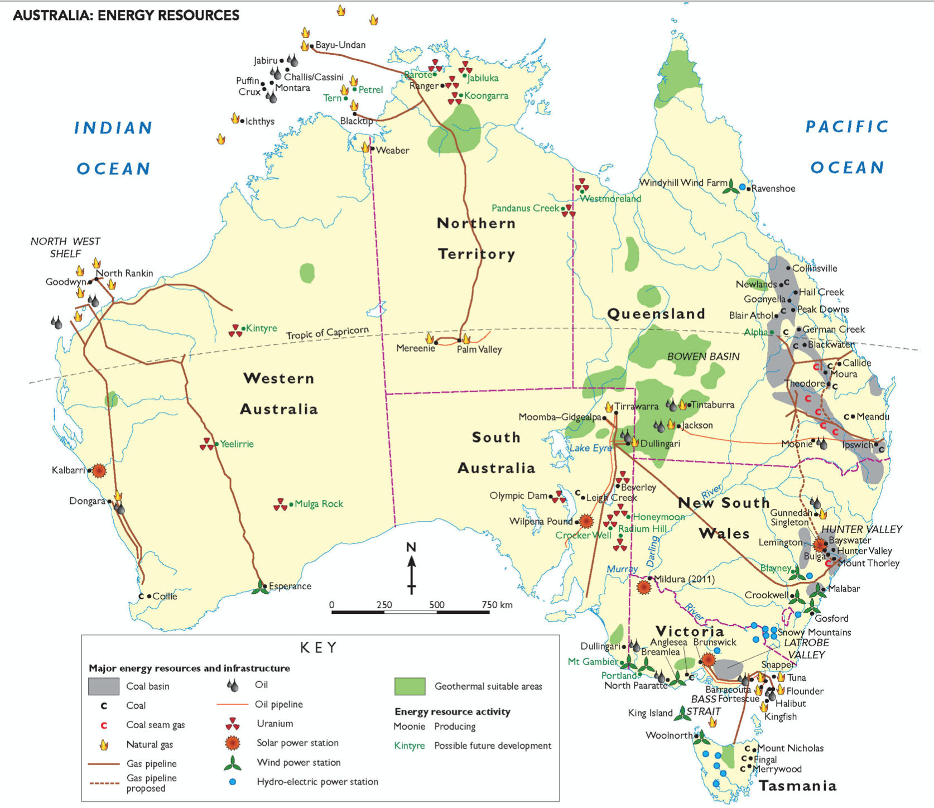

Vocabulary:
Hydroelectric = power produced by water flowing through a turbine. To create hydroelectricity, a dam must be built across a large river
Basin = a depression in the Earth's surface
Crude oil = oil that has not been refined yet into products like petrol for cars
Deposit = places where there are large concentrations of a resource, e.g. a coal deposit of a uranium deposit
Bauxite = a mineral that is used to make aluminium

Map Task:
Zoom into the map to highlight the following natural resource regions of Australia with your ePen:
- 1) Hunter and La Trobe coal valleys
- 2) North West Shelf gas region
- 3) Snowy Mountains hydroelectric resources
- 4) Bass Strait wind and gas resources
- 5) Coal basins of Queensland
- 6) Hydroelectric resources of Tasmania

- Discover- Australia's resources
Australia has more natural resources per head of population than any other country in the world. The main reason for this is that we have a small population in a very large country.

Minerals
Australia is rich in mineral resources. The Pilbara region in Western Australia, for example, has some of the largest reserves of iron ore in the world. Australia also produces many other minerals, including silver, copper, nickel and tin.
Australia is the world’s:
• largest exporter of iron ore, bauxite, lead, diamonds, zinc ores and mineral sands
• second-largest exporter of alumina (processed from bauxite and then turned into aluminium)
• third-largest exporter of gold.

Soils
Australia has generally poor soils, especially when compared with those found in other continents such as North America and Europe. Most Australian soils are low in nutrients, and in some parts of the continent, particularly the more arid areas, high salt content is also a problem. Most parts of Australia are suitable only for sheep and cattle grazing, rather than intensive agriculture, owing to low rainfall and poor soils.
There are regions of good soil scattered throughout Australia. These include soils formed from volcanic rock, such as those on the Darling Downs in Queensland and around Orange in New South Wales, and alluvial soils (found in river valleys).



Natural scenery
Australia’s spectacular scenery attracts tourists from all over the world, particularly to those sites that are on the World Heritage List. This means that they are recognised as being of global importance due to their great natural or cultural significance.

Forests
Apart from Antarctica, which has no trees, Australia is the world’s least forested continent. The most common vegetation in Australia is woodland and shrubland. Before European occupation, about nine per cent of Australia was forested. Today, about five per cent of the country is forested. Even though Australia exports timber products, it also imports a lot of timber, particularly softwoods such as pine.




- Apply- Answer the questions below
- List the main mineral resources produced in Australia.

- Refer to the case study of the Pilbara:
- Where does Australia's main iron ore production take place?

- What is the main use of iron ore?

- Why is there strong demand overseas for Australian iron ore?

- Why are many Australian soils suitable only for grazing?

- To which region of the world do most of Australia's resources go?

- What type of energy resources is most abundant in Australia?

- How does mining affect the environment. Create a flow chart, or fill in the template below (NB: use your ePen for this task. Alternatively this will need to be saved and opened in a new program)



- Review and Reflect
In pairs quiz each other on the following questions (answer below - you'll have to scroll a bit - no peeking!)
- Where in Australia are Australia's major energy resource regions and what is produced in each region?
- What resources does Australia export to the rest of the world?
- Who are the main buyers of Australian resource exports?
- What are the definitions of:
  - Hydroelectric
  - Crude oil
  - Basin
  - Deposit
  - Bauxite

Do you think Australia can rely on only the resources it has or Do you think we need help from other countries? Why?

Review answers
- Coal - La Trobe Valley in Victoria; Hunter Valley in NSW; several major coal deposits in Queensland
  - Gas - North West Shelf; Bass Strait; Timor Sea
  - Hydroelectricity - Snowy Mountains; Western Tasmania
  - Uranium - eastern parts of South Australia; far-north Northern Territory e.g. Jabiluka
  - Wind - southern Victoria; Bass Strait; eastern parts of NSW
- Iron Ore, Bauxite, Coal, Gold, Zinc, Lead, Diamonds
- China, Japan, EU, India, South Korea, other parts of Asia
- Hydroelectric = power produced by water flowing through a turbine. To create hydroelectricity, a dam must be built across a large river
Basin = a depression in the Earth's surface
Crude oil = oil that has not been refined yet into products like petrol for cars
Deposit = places where there are large concentrations of a resource, e.g. a coal deposit of a uranium deposit
Bauxite = a mineral that is used to make aluminium

1.4 How does water change places?
Wednesday, 30 October 2024
4:12 PM
How Does Water Change Places?

Learning intention | To describe and explain how the movement of water affects the landscape.  To describe and explain river erosion, deposition and meandering.  To understand how river courses change over time, according to modern science.  To understand how river courses change over time according to indigenous cultures.
Success criteria | I can define and explain erosion, deposition and meandering.  I can explain how moving water can change a landscape.  I can create a flow diagram based on the creation of the Grand Canyon  I can annotate a geographical image

ENGAGE: Aboriginal and Torres Strait Islander Perspective on forming rivers and landscapes

Watch the following video and answer the questions below:
Awakening Of The Rainbow Serpent (6mins)


What did the Earth look like before the Rainbow Serpent changed everything?

Explain how the Rainbow Serpent formed rivers

Explain how the Rainbow Serpent formed hills and mountains



Study the image above of the Murray River, and explain how the river may have been formed according to the Dreamtime perspective of the Rainbow Serpent. Write your answer below.

Remember, this is only one perspective on the formation of waterways.

Vocabulary – In this topic you will need to understand relevant terms.
Provide a definition of each of the following, with reference to a river.
  - Meander

  - Erode or Erosion

  - Sediment

  - Water Flow

  - Barren

Now use each of these terms in a separate sentence to show your understanding

DISCOVER: How Rivers Change Their Course Over Time
Rivers don’t always stay in the same place; they can change their path over time. This happens because of natural processes like erosion and deposition, and sometimes because of human activity or changes in the climate. Here’s how it works:
1. Erosion and Deposition


As rivers flow, they carry away dirt, rocks, and sand from one place to another. This is called erosion. On the outside of a river bend, where the water flows fast, the river erodes the land. On the inside of a bend, where the water moves slower, the river drops off the dirt and sand it’s carrying. This process builds up new land, creating point bars on the inside of bends, while the outside of bends keeps getting eroded and the river curves more. Over time, this creates winding curves called meanders.
2. Meandering


Rivers often end up winding back and forth across the land. The more the river curves, the more erosion happens on the outside of the bends, and more sand and dirt build up on the inside of the bends. This makes the river bend even more. As time passes, these bends can get bigger and bigger.
3. Oxbow Lakes
Sometimes, a river’s curve can get so big that it forms a narrow strip of land, and during a flood or strong current, the river might break through this narrow part and find a quicker, shorter path. When this happens, the old bend is left behind and can form a shape like a horseshoe, called an oxbow lake.
4. Flooding
Floods can also change the river's path. When rivers overflow, they can carve new channels, move dirt and rocks, or even create new paths. Floods are one of the fastest ways rivers can change where they go.



5. Human Influence
People can also change rivers. Things like dams, roads, and buildings can block or change the river’s path. When humans do this, it can make rivers change direction more quickly or in ways that wouldn’t happen naturally.



6. Climate Change
Changes in weather, like more rain or longer droughts, can affect how rivers move. More rain can cause floods, which can change the river’s path. Less rain might make the river flow more slowly and change less often.



In Summary:
Rivers change their course over time because of erosion, where they wear down the land and move dirt and rocks around. This makes rivers bend, create oxbow lakes, and sometimes change their path after floods. Humans and changes in the weather can also speed up or affect these changes.

Watch the following video and answer the questions below:
Why Do Rivers Curve?



Video Questions:
  - In your own words, explain how a muskrat might contribute to changing the direction of a river.

  - Explain how deeper curves occur within a flowing river.

  - How does an ox-bow lake or billabong form?

APPLY: Mini Case Study - The Grand Canyon
How Was the Grand Canyon Formed? (4.28mins)


After you watch the video, create an 8 step Flow Diagram to show how the Grand Canyon was formed.

Teacher note: students should include the following:

  - Mazatzal Mountains
  - Erosion of these mountains
  - Ancient oceans, deposition and layering
  - Tectonic uplift creates Rocky Mountains
  - Colorado River created by snowmelt
  - Descending river water, 0.5 million tonnes of transported material daily
  - Erosion by the Colorado River
  - Ice, rain and snow erosion of the canyon walls.

Annotate the image below of a section of the Grand Canyon, including the Colorado River. Be sure to indicate the following:
  - Erosion
  - Layering or stratification
  - Deposition
  - Meandering



Self-Assessment
Monday, 18 March 2024
3:48 PM

Student Assessment

 | Level 6 | Level 7 | Level 8 | Level 9 | Level 10 | Level 11
1.1 Characteristics of place | I can identify diverse characteristics of places. | I can explain diverse characteristics of places. | I can explain processes that influence characteristics of places. | I can predict changes in the characteristics of places over time. | I can identify the implications of change for the future. | I can synthesise multiple data sources to provide analysis about the predicted changes.
2.1 Map and Data Analyses | I can identify the key features of a map (BOLTSS). | I can use geographical language to interpret increases, decreases or trends in maps, graphs, charts, or tables. | I can describe patterns, quantify them, and point out exceptions in maps, graphs, charts, or tables. | I can use social, historical, environmental, economic, political or technological factors (SHEEPT) to explain trends in maps, graphs, charts, or tables. | I can analyse relationships between multiple sources of geographical data. | I can analyse and draw reasoned conclusions from independently collected sources of geographical data.

Teacher Assessment

 | Level 6 | Level 7 | Level 8 | Level 9 | Level 10 | Level 11
1.1 Characteristics of place | I can identify diverse characteristics of places. | I can explain diverse characteristics of places. | I can explain processes that influence characteristics of places. | I can predict changes in the characteristics of places over time. | I can identify the implications of change for the future. | I can synthesise multiple data sources to provide analysis about the predicted changes.
2.1 Map and Data Analyses | I can identify the key features of a map (BOLTSS). | I can use geographical language to interpret increases, decreases or trends in maps, graphs, charts, or tables. | I can describe patterns, quantify them, and point out exceptions in maps, graphs, charts, or tables. | I can use social, historical, environmental, economic, political or technological factors (SHEEPT) to explain trends in maps, graphs, charts, or tables. | I can analyse relationships between multiple sources of geographical data. | I can analyse and draw reasoned conclusions from independently collected sources of geographical data.

Topic 2 - Water Uses as a Resource
Saturday, 16 June 2018
12:01 PM



The amount of water on Earth has not changed since the beginning of time; there is only a finite, or fixed, amount. The water used by ancient and extinct animals and plants millions of years ago is the same water that today falls as rain. The amount of water cannot be increased or decreased. It is cycled and recycled, and constantly changes its state from gas, to liquid, to solid, and back.

Water is a resource. Like any other resource, it has no value in itself, but has great value when a use is found for it. Environments where water is found are also a resource. A river can be the site of a settlement that provides transport as well as food. A riverine environment that includes fish, birds, wildlife, wetlands, plants and micro-organisms is also valuable as a living system and can therefore be regarded as a resource.

JacPlus Textbook Reading
  - Chapter 2.7 - Is water a renewable resource?
  - Chapter 2.9 - How is groundwater used as a resource?

2.1 Water Uses
Monday, 16 July 2018
8:07 PM
Learning intention | To describe the multiple and competing uses of water  To learn water-saving tips for home water use
Success criteria | I can identify and describe the stages of the water cycle  I can explain and describe the uses of water  I have analysed and discussed ways of saving water around the home
Vocabulary | Irrigation: Widespread watering of farmland
Content for Self-Assessment | Map and Data Analysis  Interconnection

Lesson Focus: How do humans use water?

  - Engage

List 5 ways that you use water on a daily basis?

  - Discover - Interconnection


Since the beginning of human history, we have relied on water. We drink it in order to survive. We wash, cook and clean with it and we use it to grow our food and produce electricity. In this way, water is arguably our most precious resource. Life on Earth without it would be impossible. One of the challenges facing Australia today is that we use too much of this environmental resource.

Match the water use to its explanation:

Suggestion: Print this table out and cut it up. Give half the class a term and the other half a definition. Students then need to find their partner. Once they have done that, they need to sit down with their partner and explain to the rest of the class why they have chosen each other. Then, as a group, write in the correct numbers in the blank column based on the student responses.

1 | Irrigation of parks, gardens and sporting grounds | 4 | The average Australia household uses over 350 litres of water a day for drinking, preparing food, washing, cleaning, flushing toilets, cleaning cars, and water lawns and gardens. Toilets and bathrooms account for about 40 per cent of this domestic water use.
2 | Environmental needs | 8 | Large rivers (such as the Nile in Egypt, the Rhine in Europe and the Yangtze in China) have been used for centuries for trade, as they provide a fast method of transporting goods between regions and countries.
3 | Irrigation of crops and pastures | 9 | Electricity can be generated from the energy of moving water. Usually, to do this a dam must be constructed across a river and a lake formed behind it. This allows the river's flow to be controlled and released through the dam to produce electricity.
4 | Domestic uses | 1 | Many parks, gardens and sporting grounds, including football ovals, rely heavily on water in order to survive. In dry areas, water is often taken from drinking shortages to keep them green and healthy. This is the number use of water in Australia.
5 | Firefighting | 14 | Commercial and recreational fishing depends on clean oceans, rivers and lakes.
6 | Spiritual uses | 2 | As well as being used for human consumption, fresh water is a vital part of the natural environment. Taking too much water from a river can cause many environmental problems, such as weed growth, fish deaths and salt build-up.
7 | Power generation: coal-fired and nuclear power | 11 | The construction industry relies heavily on water in order to make concrete and many building supplies, such as bricks. Many industrial processes use large quantities of water for cooling and cleaning.
8 | Navigation and trade | 3 | Irrigation accounts for most of the world's water use. In some arid areas, including many parts of Australia, irrigation is use to grow crops. So water provides us with our food as well as our drink.
9 | Power generation: hydroelectric power | 12 | The mining industry relies heavily on water to cool machinery, enable drilling and process minerals and iron ore taken from the ground.
10 | Snow-making | 13 | Recreational activities (such as water-skiing and swimming) generally have little impact on the quantity and quality of fresh water. Pollutants in the water from industry upstream can affect water quality and make the water unsuitable for recreation.
11 | Construction and industry | 7 | Virtually all power stations use large quantities of water. Coal-fired power stations heat water to produce steam that turns turbines to create electricity. Water is also used to cool the station. Nuclear power plants operate in much the same way.
12 | Mining | 5 | Firefighters around the world rely heavily on a constant supply of water in order to carry out their work.
13 | Recreational activities | 10 | Artificial snow-making is important in countries such as Australia where natural snowfalls can be infrequent. However, many countries with more regular snowfalls now also use snow-making machines in order to improve conditions and attract more tourists.
14 | Fishing | 6 | Water holds a special significance for almost all world religions. It often plays a key part in religious ceremonies.

  - Apply:

  - What activity uses the most water in Australia? How much of our water does it use?
  - How can water be used to help create electricity?
  - Identify two water uses that might impact one another.

  - Review and Reflect – Map and Data Analysis

Water usage worksheet (print)
<<Water Usage Worksheet.pdf>>

Using this Table as a guide complete the water use handout and see how much water your household uses every week

Washing hands | 2.5 litres per wash
Showering | 15 litres per minute
Brushing Teeth | 15 litres water running/ 1 litre no running water
Drinking Water | 3-4 litres of water per day
Toilet Use | 3 litres per half flush/ 4.5 per full flush
Washing Machine Use | 60 litres Front Loader / 80 litres Top Loader per wash
Dishwasher Use | 13-18 litres per wash
Handwashing Dishes | 4-6 litres per minute.
Pool Maintenance/Top Up | 750 litres per week
Leaking Taps | 200 Litres per week, per tap.

<<Water use chart.pdf>>

2.2 The World's Water
Monday, 16 July 2018
9:01 AM

Lesson focus: Where is the world's water?

Learning intention | To describe and analyse water as a limited and essential resource
Success criteria | I can identify the features of water as a limited resource  I can compare the uses for water between countries  I can analyse patterns on a map
Content for Self-Assessment | Map and Data Analysis

For this lesson, you will be introduced to facts about the world’s water through the studying and analysis of various infographics.

  - Engage: Watch
Water Crisis - A short introduction



  - Develop and Discover: Map and Data Analysis

Infographics:

Study the below infographics and using the information provided and your own knowledge, answer the questions below.

Figure 1.



Figure 2.


Figure 3.
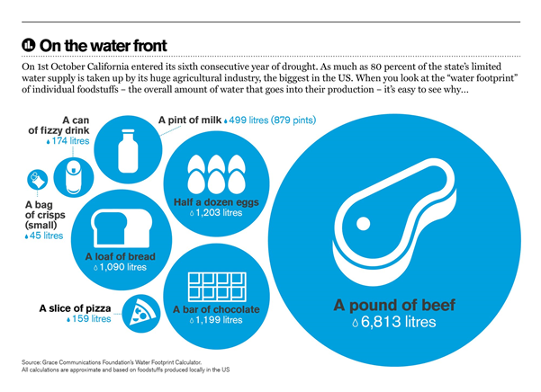

Answer

  - What percent of the Earth's water is fresh?
  - How much water is found in rivers, lakes, wetlands, and ground water?
  - Why do some places have more water than other places?
  - Explain what makes water accessible and useable with reference to some of the barriers to water being accessible and useable.

  - Apply: Map and Data Analysis - PQE Analysis (Pattern Quantification Exception)

Map analysis- Figure 1.


In figure 1, describe how much rain fall there is in North Africa and the Middle East

In figure 1, which countries are affected by the tropical rainfall

Write a PQE paragraph based on Figure 1 map
P-
Q-
E-

Review and Reflect

Step 1. Each student will receive a country
Step 2. Find the rainfall for your country on the map above
Step 3. Organise yourselves in order of highest rainfall to lowest.
Step 4. Quiz the students random

  - Review and Reflect

Why are there so many 'unseen leaks' for freshwater in Developing countries?

2.3 The Significance of Water
Monday, 4 July 2022
5:39 PM
Lesson Focus: The Value and Significance of Water

Learning intention | To describe the significance and value of water on the First Nations People of Australia
Success criteria | I can identify and explain the uses of water in Aboriginal communities.  I can explain the spiritual perspective of water sources of Aboriginal people.  I can discuss the potential solutions to balance consumption and sustainability of water sources.
Content for Self-Assessment | Interconnection

- Engage: Watch and Answer
That's My Water! NT: Water in traditional culture


- The video mentions that water is 'precious' for many reasons, identify what these reasons were.
- According to the video, identify the dreamtime stories that are told about water.
- Identify three new things you learnt from the video and share them with the class.

- Discover and Develop
Complete the table below about the different values of water to First Nations Peoples. An example has been done for you

Value Type | Meaning | Example
Aesthetic value | attractiveness of a landscape or landform | The beauty of the beach
Economic value
Cultural value
Spiritual value

Case study: Custodians of the River
<<Custodians of the River.pdf>>

- Apply

In groups of three, each read and take notes from one of the sections of The Guardian article, ‘Fitzroy River: the push to prevent a repeat of the Murray-Darling Basin disaster’.
Linked here: https://www.theguardian.com/australia-news/2020/sep/06/fitzroy-river-the-push-to-prevent-a-repeat-of-the-murray-darling-basin-disaster

Choose one from the following 3 sections:
- Section 1: Read from the start up to the subheading ‘It has a right to life’ (588 words, 4-minute read).
- Section 2: Read from ‘It has a right to life’ to the subheading ‘The Martuwarra Fitzroy River Council’ (736 words, 5-minute read), including video (01:43).
- Section 3: Read from the subheading ‘The Martuwarra Fitzroy River Council’ (588 words, 4-minute read), including video (01:40).
Write down key information as you read and report back to the group to share your notes.
Use the template to guide your notes



- Review and Reflect
Write a TEEL paragraph that identifies a significant water value for First Nations people and explain its importance.

Further teacher reading:
Case study: In what ways is water important to First Nations Peoples in Australia?
Y7_Geography_Values-of-water_AC9HG7K01_K02_K03_AC9HG7S01_S04_Student-Handouts.pdf



Why is it important to understand the spiritual perspective of water sources of the Aboriginal people in these communities?

  - Review and Reflect - Interconnection



In pairs or small groups, discuss some potential solutions to resolving conflicting values of water?

Self Assessment
Monday, 18 March 2024
3:46 PM

Student Assessment
 | Level 6 | Level 7 | Level 8 | Level 9 | Level 10 | Level 11
1.2 Interconnection | I can identify how places, people, and environments are connected. | I can identify interconnections within and between places, people, and environments. | I can describe interconnections within and between places, people, and environments. | I can explain interconnections within and between places, people, and environments over time and at different scales. | I can analyse interconnections within and between places, people and environments over time and at different scales. | I can synthesise multiple data sources to analyse interconnections within and between places, people and environments.
2.1 Map and Data Analyses | I can identify the key features of a map (BOLTSS). | I can use geographical language to interpret increases, decreases or trends in maps, graphs, charts, or tables. | I can describe patterns, quantify them, and point out exceptions in maps, graphs, charts, or tables. | I can use social, historical, environmental, economic, political or technological factors (SHEEPT) to explain trends in maps, graphs, charts, or tables. | I can analyse relationships between multiple sources of geographical data. | I can analyse and draw reasoned conclusions from independently collected sources of geographical data.

Teacher Assessment
 | Level 6 | Level 7 | Level 8 | Level 9 | Level 10 | Level 11
1.2 Interconnection | I can identify how places, people, and environments are connected. | I can identify interconnections within and between places, people, and environments. | I can describe interconnections within and between places, people, and environments. | I can explain interconnections within and between places, people, and environments over time and at different scales. | I can analyse interconnections within and between places, people and environments over time and at different scales. | I can synthesise multiple data sources to analyse interconnections within and between places, people and environments.
2.1 Map and Data Analyses | I can identify the key features of a map (BOLTSS). | I can use geographical language to interpret increases, decreases or trends in maps, graphs, charts, or tables. | I can describe patterns, quantify them, and point out exceptions in maps, graphs, charts, or tables. | I can use social, historical, environmental, economic, political or technological factors (SHEEPT) to explain trends in maps, graphs, charts, or tables. | I can analyse relationships between multiple sources of geographical data. | I can analyse and draw reasoned conclusions from independently collected sources of geographical data.

Topic 3 - Water Related Hazards and Disasters
Monday, 16 July 2018
8:07 PM

3.1 Hazards & Disasters
Tuesday, 11 September 2018
00:24

Learning intention | To understand hazards, disasters, and strategies to respond to them.
Success criteria | I can identify and explain the difference between natural hazard and natural disaster.  I can describe the different types of hazards.  I can identify and analyse the effect these hazards have on people.  I can explain strategies to respond to hazards and disasters.
Content for self-assessment | Interconnections & Challenges



- Engage

Types of Hazards

<<Hazards and Disasters.pptx>>

- Discover

Apply your knowledge

What are the three factors that impact weather conditions?

What is the difference between weather and climate?

Define:
Natural Hazard

Natural Disaster

What is the difference between a disaster and a hazard?

Define and give an example of:
An atmospheric natural hazard

A hydrological hazard

A geological hazard

A biological hazard

- Apply - Strategies to Respond to Geographical Challenges

Today you will research several different hazards and complete your data table. As part of your research you will include the following:

- Explain what it is.
- How does it form?
- What can be the impact of your hazard?
- How should people prepare for your hazard?
- How do people respond?
- Recent example from Australia or overseas

Research Table

Topic | What is it? | How does it form? | What is the impact? | How do people prepare? | How do people respond? | Recent example from Australia or Overseas
Thunderstorm
Hailstorm
Cyclone
Typhoon
Tornado

- Review and Reflect - Geographical Challenges

Watch

The Chernobyl Disaster: How It Happened



As a class , Discuss the what type of Hazard and Disaster the Chernobyl Plant was.

3.2 Droughts and Floods
Tuesday, 11 September 2018
00:23
Lesson Focus: Understand the why droughts and floods occur and the impact that they have on our world.

Learning intention | To understand the cause and impact of weather events that lead to floods and droughts in Australia and around the world.
Success criteria | I can identify and explain the features and types of droughts and floods  I can describe the impact droughts and floods have on people and the environment  I can create my own learning resource that can test my knowledge of droughts and floods
Content for Self-Assessment | Interconnections & Challenges

Engage

Watch

El Nino and La Nina






Discover

As a class we will go through this PowerPoint to support your Learning

<<Droughts and Floods.pptx>>

Answer the following Questions

Define drought

Why does Australia experience drought?

Define:
El Niño

La Nina

Southern Oscillation

Explain one impact of a drought - Interconnections between people and environment

Define floods

Identify the different types of floods

Explain one impact of a flood - Interconnections between people and environment

Apply

Create your own Class Trivia!

Using the information above, and your own research, create your own trivia question on the topic of droughts and floods. Each student will be allocated a topic form the list below. You will create one question each.

- El Nino
- La Nina
- Southern Oscillation
- Impacts of droughts
- Impacts of floods

Review and Reflect.

Time permitting, we will play the trivia game as a class

Self-Assessment
Monday, 18 March 2024
3:58 PM

Student Assessment

 | Level 6 | Level 7 | Level 8 | Level 9 | Level 10 | Level 11
1.2 Interconnections | I can identify how places, people, and environments are connected. | I can identify interconnections within and between places, people, and environments. | I can describe interconnections within and between places, people, and environments. | I can explain interconnections within and between places, people, and environments over time and at different scales. | I can analyse interconnections within and between places, people and environments over time and at different scales. | I can synthesise multiple data sources to analyse interconnections within and between places, people and environments.
1.3 Challenges | I can identify responses to a geographical challenge. | I can identify and compare strategies to respond to a geographical challenge. | I can compare strategies to respond to a geographical challenge and predict the likely outcomes. | I can evaluate alternative views and strategies to respond to a geographical challenge. | I can evaluate alternative views and responses to a geographical challenge and explain the predicted outcomes. | I can evaluate alternative views and responses to a geographical challenge and draw a conclusion about the most effective response.

Teacher Assessment

 | Level 6 | Level 7 | Level 8 | Level 9 | Level 10 | Level 11
1.2 Interconnections | I can identify how places, people, and environments are connected. | I can identify interconnections within and between places, people, and environments. | I can describe interconnections within and between places, people, and environments. | I can explain interconnections within and between places, people, and environments over time and at different scales. | I can analyse interconnections within and between places, people and environments over time and at different scales. | I can synthesise multiple data sources to analyse interconnections within and between places, people and environments.
1.3 Challenges | I can identify responses to a geographical challenge. | I can identify and compare strategies to respond to a geographical challenge. | I can compare strategies to respond to a geographical challenge and predict the likely outcomes. | I can evaluate alternative views and strategies to respond to a geographical challenge. | I can evaluate alternative views and responses to a geographical challenge and explain the predicted outcomes. | I can evaluate alternative views and responses to a geographical challenge and draw a conclusion about the most effective response.

1.2 Australia's Natural Resources
Saturday, 16 June 2018
12:01 PM
Learning intention | To explain the importance of natural resources to Australia
Success criteria | I can identify major energy resources in regions of Australia  I can explain and describe the use and importance of resources in Australia  I can appraise my knowledge of Australia's resources with a peer or family member
Content for Self-Assessment | Place & Map and Data Analyses

- Engage: Which natural resources are abundant in Australia?



Vocabulary:
Hydroelectric = power produced by water flowing through a turbine. To create hydroelectricity, a dam must be built across a large river
Basin = a depression in the Earth's surface
Crude oil = oil that has not been refined yet into products like petrol for cars
Deposit = places where there are large concentrations of a resource, e.g. a coal deposit of a uranium deposit
Bauxite = a mineral that is used to make aluminium

Map Task:
Zoom into the map to highlight the following natural resource regions of Australia with your ePen:
- 1) Hunter and La Trobe coal valleys
- 2) North West Shelf gas region
- 3) Snowy Mountains hydroelectric resources
- 4) Bass Strait wind and gas resources
- 5) Coal basins of Queensland
- 6) Hydroelectric resources of Tasmania

- Discover- Australia's resources
Australia has more natural resources per head of population than any other country in the world. The main reason for this is that we have a small population in a very large country.

Minerals
Australia is rich in mineral resources. The Pilbara region in Western Australia, for example, has some of the largest reserves of iron ore in the world. Australia also produces many other minerals, including silver, copper, nickel and tin.
Australia is the world’s:
• largest exporter of iron ore, bauxite, lead, diamonds, zinc ores and mineral sands
• second-largest exporter of alumina (processed from bauxite and then turned into aluminium)
• third-largest exporter of gold.

Soils
Australia has generally poor soils, especially when compared with those found in other continents such as North America and Europe. Most Australian soils are low in nutrients, and in some parts of the continent, particularly the more arid areas, high salt content is also a problem. Most parts of Australia are suitable only for sheep and cattle grazing, rather than intensive agriculture, owing to low rainfall and poor soils.
There are regions of good soil scattered throughout Australia. These include soils formed from volcanic rock, such as those on the Darling Downs in Queensland and around Orange in New South Wales, and alluvial soils (found in river valleys).



Natural scenery
Australia’s spectacular scenery attracts tourists from all over the world, particularly to those sites that are on the World Heritage List. This means that they are recognised as being of global importance due to their great natural or cultural significance.

Forests
Apart from Antarctica, which has no trees, Australia is the world’s least forested continent. The most common vegetation in Australia is woodland and shrubland. Before European occupation, about nine per cent of Australia was forested. Today, about five per cent of the country is forested. Even though Australia exports timber products, it also imports a lot of timber, particularly softwoods such as pine.




- Apply- Answer the questions below
- List the main mineral resources produced in Australia.

- Refer to the case study of the Pilbara:
- Where does Australia's main iron ore production take place?

- What is the main use of iron ore?

- Why is there strong demand overseas for Australian iron ore?

- Why are many Australian soils suitable only for grazing?

- To which region of the world do most of Australia's resources go?

- What type of energy resources is most abundant in Australia?

- How does mining affect the environment. Create a flow chart, or fill in the template below (NB: use your ePen for this task. Alternatively this will need to be saved and opened in a new program)



- Review and Reflect
In pairs quiz each other on the following questions (answer below - you'll have to scroll a bit - no peeking!)
- Where in Australia are Australia's major energy resource regions and what is produced in each region?
- What resources does Australia export to the rest of the world?
- Who are the main buyers of Australian resource exports?
- What are the definitions of:
  - Hydroelectric
  - Crude oil
  - Basin
  - Deposit
  - Bauxite

Do you think Australia can rely on only the resources it has or Do you think we need help from other countries? Why?

Review answers
- Coal - La Trobe Valley in Victoria; Hunter Valley in NSW; several major coal deposits in Queensland
  - Gas - North West Shelf; Bass Strait; Timor Sea
  - Hydroelectricity - Snowy Mountains; Western Tasmania
  - Uranium - eastern parts of South Australia; far-north Northern Territory e.g. Jabiluka
  - Wind - southern Victoria; Bass Strait; eastern parts of NSW
- Iron Ore, Bauxite, Coal, Gold, Zinc, Lead, Diamonds
- China, Japan, EU, India, South Korea, other parts of Asia
- Hydroelectric = power produced by water flowing through a turbine. To create hydroelectricity, a dam must be built across a large river
Basin = a depression in the Earth's surface
Crude oil = oil that has not been refined yet into products like petrol for cars
Deposit = places where there are large concentrations of a resource, e.g. a coal deposit of a uranium deposit
Bauxite = a mineral that is used to make aluminium

1.1 The Water Cycle
Lesson Focus: What is the water cycle?

Learning intention | To describe and explain types of rainfall and the stages of the water cycle.  To describe different types of rainfall.  To describe Australia's rainfall distribution using PQE method.
Success criteria | I can explain the water cycle.  I can explain and distinguish the different types of rainfall  I can explain Australia's rainfall distribution using PQE method.
Content for Self-Assessment | Map and Data Analyses

- Engage: Play and Watch (hook)

The Great Aqua Adventure: Crash Course Kids #24.1



- Discover and develop

Water is one of our most precious environmental resources. Without it, nothing can survive. It is an essential, renewable resource that occurs naturally on Earth. It can exist as a solid (such as ice in a glacier), a liquid (such as water in a river) or a gas (such as steam). Fresh water is an available resource when in liquid form and a potential resource as a gas or a solid. Liquid water is constantly being recycled through the atmosphere, rivers and oceans in a natural system known as the water cycle.

Write a definition for each of these words: precipitation, condensation and evaporation.
Word | Definition
Precipitation
Condensation
Evaporation
Transpiration

Draw the Water Cycle in your work books.


Include the following words in your picture:

Evaporation
Precipitation
Condensation
Transpiration

Take a look at the Urban Water Cycle.


Answer the following questions:
- Describe the connection between fresh water, storm water and waste water.

- What are the potential effects on people and the environment when using this kind of water management?

- What is one similarity between the Water Cycle and the Urban Water Cycle

- What is one difference between the Water Cycle and the Urban Water Cycle

- Apply
PQE stands for Pattern, Quantify and Exception. When looking at a map or graph, in order to determine the trends and distribution shown, you can use this method to complete your analysis of the graph.

Referring to the graph below - complete a PQE and use the table to guide you in completing it.
P - requires you to look at the pattern and trends in the information. Think: if you had to describe general consistencies, how would you describe that?
Q - requires you to numerically justify the pattern you have observed using data from the information provided. Think: if you had to support the pattern you identified, what data could you include to support it?
E - requires you to find the exceptions to the pattern, what are the outliers? Think: if there is a pattern that isn't consistent with the rest, what is it?



PQE | Sentence Starters (select one) | Your Response
Pattern | - The pattern shown…  - The trend of…  - Consistent across Australia is…
Quantify | -This is shown by…  -This is evident as…
Exception | - The exception to this is…  - The outlier to this is…

- Review and Reflect

Kahoot - Fun water facts https://create.kahoot.it/v2/share/amazing-water-facts/bb115294-ba7c-4388-bd2f-53666deb21d8

Additional Activities- Extension Water Cycle Game - Fun, 20 minutes, gets students moving:
<<Water Cycle Game.pdf>>

1.2 Australia's Natural Resources
Saturday, 16 June 2018
12:01 PM
Learning intention | To explain the importance of natural resources to Australia
Success criteria | I can identify major energy resources in regions of Australia  I can explain and describe the use and importance of resources in Australia  I can appraise my knowledge of Australia's resources with a peer or family member
Content for Self-Assessment | Place & Map and Data Analyses

- Engage: Which natural resources are abundant in Australia?



Vocabulary:
Hydroelectric = power produced by water flowing through a turbine. To create hydroelectricity, a dam must be built across a large river
Basin = a depression in the Earth's surface
Crude oil = oil that has not been refined yet into products like petrol for cars
Deposit = places where there are large concentrations of a resource, e.g. a coal deposit of a uranium deposit
Bauxite = a mineral that is used to make aluminium

Map Task:
Zoom into the map to highlight the following natural resource regions of Australia with your ePen:
- 1) Hunter and La Trobe coal valleys
- 2) North West Shelf gas region
- 3) Snowy Mountains hydroelectric resources
- 4) Bass Strait wind and gas resources
- 5) Coal basins of Queensland
- 6) Hydroelectric resources of Tasmania

- Discover- Australia's resources
Australia has more natural resources per head of population than any other country in the world. The main reason for this is that we have a small population in a very large country.

Minerals
Australia is rich in mineral resources. The Pilbara region in Western Australia, for example, has some of the largest reserves of iron ore in the world. Australia also produces many other minerals, including silver, copper, nickel and tin.
Australia is the world’s:
• largest exporter of iron ore, bauxite, lead, diamonds, zinc ores and mineral sands
• second-largest exporter of alumina (processed from bauxite and then turned into aluminium)
• third-largest exporter of gold.

Soils
Australia has generally poor soils, especially when compared with those found in other continents such as North America and Europe. Most Australian soils are low in nutrients, and in some parts of the continent, particularly the more arid areas, high salt content is also a problem. Most parts of Australia are suitable only for sheep and cattle grazing, rather than intensive agriculture, owing to low rainfall and poor soils.
There are regions of good soil scattered throughout Australia. These include soils formed from volcanic rock, such as those on the Darling Downs in Queensland and around Orange in New South Wales, and alluvial soils (found in river valleys).



Natural scenery
Australia’s spectacular scenery attracts tourists from all over the world, particularly to those sites that are on the World Heritage List. This means that they are recognised as being of global importance due to their great natural or cultural significance.

Forests
Apart from Antarctica, which has no trees, Australia is the world’s least forested continent. The most common vegetation in Australia is woodland and shrubland. Before European occupation, about nine per cent of Australia was forested. Today, about five per cent of the country is forested. Even though Australia exports timber products, it also imports a lot of timber, particularly softwoods such as pine.




- Apply- Answer the questions below
- List the main mineral resources produced in Australia.

- Refer to the case study of the Pilbara:
- Where does Australia's main iron ore production take place?

- What is the main use of iron ore?

- Why is there strong demand overseas for Australian iron ore?

- Why are many Australian soils suitable only for grazing?

- To which region of the world do most of Australia's resources go?

- What type of energy resources is most abundant in Australia?

- How does mining affect the environment. Create a flow chart, or fill in the template below (NB: use your ePen for this task. Alternatively this will need to be saved and opened in a new program)



- Review and Reflect
In pairs quiz each other on the following questions (answer below - you'll have to scroll a bit - no peeking!)
- Where in Australia are Australia's major energy resource regions and what is produced in each region?
- What resources does Australia export to the rest of the world?
- Who are the main buyers of Australian resource exports?
- What are the definitions of:
  - Hydroelectric
  - Crude oil
  - Basin
  - Deposit
  - Bauxite

Do you think Australia can rely on only the resources it has or Do you think we need help from other countries? Why?

Review answers
- Coal - La Trobe Valley in Victoria; Hunter Valley in NSW; several major coal deposits in Queensland
  - Gas - North West Shelf; Bass Strait; Timor Sea
  - Hydroelectricity - Snowy Mountains; Western Tasmania
  - Uranium - eastern parts of South Australia; far-north Northern Territory e.g. Jabiluka
  - Wind - southern Victoria; Bass Strait; eastern parts of NSW
- Iron Ore, Bauxite, Coal, Gold, Zinc, Lead, Diamonds
- China, Japan, EU, India, South Korea, other parts of Asia
- Hydroelectric = power produced by water flowing through a turbine. To create hydroelectricity, a dam must be built across a large river
Basin = a depression in the Earth's surface
Crude oil = oil that has not been refined yet into products like petrol for cars
Deposit = places where there are large concentrations of a resource, e.g. a coal deposit of a uranium deposit
Bauxite = a mineral that is used to make aluminium

1.4 How does water change places?
Wednesday, 30 October 2024
4:12 PM
How Does Water Change Places?

Learning intention | To describe and explain how the movement of water affects the landscape.  To describe and explain river erosion, deposition and meandering.  To understand how river courses change over time, according to modern science.  To understand how river courses change over time according to indigenous cultures.
Success criteria | I can define and explain erosion, deposition and meandering.  I can explain how moving water can change a landscape.  I can create a flow diagram based on the creation of the Grand Canyon  I can annotate a geographical image

ENGAGE: Aboriginal and Torres Strait Islander Perspective on forming rivers and landscapes

Watch the following video and answer the questions below:
Awakening Of The Rainbow Serpent (6mins)


What did the Earth look like before the Rainbow Serpent changed everything?

Explain how the Rainbow Serpent formed rivers

Explain how the Rainbow Serpent formed hills and mountains



Study the image above of the Murray River, and explain how the river may have been formed according to the Dreamtime perspective of the Rainbow Serpent. Write your answer below.

Remember, this is only one perspective on the formation of waterways.

Vocabulary – In this topic you will need to understand relevant terms.
Provide a definition of each of the following, with reference to a river.
  - Meander

  - Erode or Erosion

  - Sediment

  - Water Flow

  - Barren

Now use each of these terms in a separate sentence to show your understanding

DISCOVER: How Rivers Change Their Course Over Time
Rivers don’t always stay in the same place; they can change their path over time. This happens because of natural processes like erosion and deposition, and sometimes because of human activity or changes in the climate. Here’s how it works:
1. Erosion and Deposition


As rivers flow, they carry away dirt, rocks, and sand from one place to another. This is called erosion. On the outside of a river bend, where the water flows fast, the river erodes the land. On the inside of a bend, where the water moves slower, the river drops off the dirt and sand it’s carrying. This process builds up new land, creating point bars on the inside of bends, while the outside of bends keeps getting eroded and the river curves more. Over time, this creates winding curves called meanders.
2. Meandering


Rivers often end up winding back and forth across the land. The more the river curves, the more erosion happens on the outside of the bends, and more sand and dirt build up on the inside of the bends. This makes the river bend even more. As time passes, these bends can get bigger and bigger.
3. Oxbow Lakes
Sometimes, a river’s curve can get so big that it forms a narrow strip of land, and during a flood or strong current, the river might break through this narrow part and find a quicker, shorter path. When this happens, the old bend is left behind and can form a shape like a horseshoe, called an oxbow lake.
4. Flooding
Floods can also change the river's path. When rivers overflow, they can carve new channels, move dirt and rocks, or even create new paths. Floods are one of the fastest ways rivers can change where they go.



5. Human Influence
People can also change rivers. Things like dams, roads, and buildings can block or change the river’s path. When humans do this, it can make rivers change direction more quickly or in ways that wouldn’t happen naturally.



6. Climate Change
Changes in weather, like more rain or longer droughts, can affect how rivers move. More rain can cause floods, which can change the river’s path. Less rain might make the river flow more slowly and change less often.



In Summary:
Rivers change their course over time because of erosion, where they wear down the land and move dirt and rocks around. This makes rivers bend, create oxbow lakes, and sometimes change their path after floods. Humans and changes in the weather can also speed up or affect these changes.

Watch the following video and answer the questions below:
Why Do Rivers Curve?



Video Questions:
  - In your own words, explain how a muskrat might contribute to changing the direction of a river.

  - Explain how deeper curves occur within a flowing river.

  - How does an ox-bow lake or billabong form?

APPLY: Mini Case Study - The Grand Canyon
How Was the Grand Canyon Formed? (4.28mins)


After you watch the video, create an 8 step Flow Diagram to show how the Grand Canyon was formed.

Teacher note: students should include the following:

  - Mazatzal Mountains
  - Erosion of these mountains
  - Ancient oceans, deposition and layering
  - Tectonic uplift creates Rocky Mountains
  - Colorado River created by snowmelt
  - Descending river water, 0.5 million tonnes of transported material daily
  - Erosion by the Colorado River
  - Ice, rain and snow erosion of the canyon walls.

Annotate the image below of a section of the Grand Canyon, including the Colorado River. Be sure to indicate the following:
  - Erosion
  - Layering or stratification
  - Deposition
  - Meandering



Topic 2 - Water Uses as a Resource
Saturday, 16 June 2018
12:01 PM



The amount of water on Earth has not changed since the beginning of time; there is only a finite, or fixed, amount. The water used by ancient and extinct animals and plants millions of years ago is the same water that today falls as rain. The amount of water cannot be increased or decreased. It is cycled and recycled, and constantly changes its state from gas, to liquid, to solid, and back.

Water is a resource. Like any other resource, it has no value in itself, but has great value when a use is found for it. Environments where water is found are also a resource. A river can be the site of a settlement that provides transport as well as food. A riverine environment that includes fish, birds, wildlife, wetlands, plants and micro-organisms is also valuable as a living system and can therefore be regarded as a resource.

JacPlus Textbook Reading
  - Chapter 2.7 - Is water a renewable resource?
  - Chapter 2.9 - How is groundwater used as a resource?

1.1 The Water Cycle
Lesson Focus: What is the water cycle?

Learning intention | To describe and explain types of rainfall and the stages of the water cycle.  To describe different types of rainfall.  To describe Australia's rainfall distribution using PQE method.
Success criteria | I can explain the water cycle.  I can explain and distinguish the different types of rainfall  I can explain Australia's rainfall distribution using PQE method.
Content for Self-Assessment | Map and Data Analyses

- Engage: Play and Watch (hook)

The Great Aqua Adventure: Crash Course Kids #24.1



- Discover and develop

Water is one of our most precious environmental resources. Without it, nothing can survive. It is an essential, renewable resource that occurs naturally on Earth. It can exist as a solid (such as ice in a glacier), a liquid (such as water in a river) or a gas (such as steam). Fresh water is an available resource when in liquid form and a potential resource as a gas or a solid. Liquid water is constantly being recycled through the atmosphere, rivers and oceans in a natural system known as the water cycle.

Write a definition for each of these words: precipitation, condensation and evaporation.
Word | Definition
Precipitation
Condensation
Evaporation
Transpiration

Draw the Water Cycle in your work books.


Include the following words in your picture:

Evaporation
Precipitation
Condensation
Transpiration

Take a look at the Urban Water Cycle.


Answer the following questions:
- Describe the connection between fresh water, storm water and waste water.

- What are the potential effects on people and the environment when using this kind of water management?

- What is one similarity between the Water Cycle and the Urban Water Cycle

- What is one difference between the Water Cycle and the Urban Water Cycle

- Apply
PQE stands for Pattern, Quantify and Exception. When looking at a map or graph, in order to determine the trends and distribution shown, you can use this method to complete your analysis of the graph.

Referring to the graph below - complete a PQE and use the table to guide you in completing it.
P - requires you to look at the pattern and trends in the information. Think: if you had to describe general consistencies, how would you describe that?
Q - requires you to numerically justify the pattern you have observed using data from the information provided. Think: if you had to support the pattern you identified, what data could you include to support it?
E - requires you to find the exceptions to the pattern, what are the outliers? Think: if there is a pattern that isn't consistent with the rest, what is it?



PQE | Sentence Starters (select one) | Your Response
Pattern | - The pattern shown…  - The trend of…  - Consistent across Australia is…
Quantify | -This is shown by…  -This is evident as…
Exception | - The exception to this is…  - The outlier to this is…

- Review and Reflect

Kahoot - Fun water facts https://create.kahoot.it/v2/share/amazing-water-facts/bb115294-ba7c-4388-bd2f-53666deb21d8

Additional Activities- Extension Water Cycle Game - Fun, 20 minutes, gets students moving:
<<Water Cycle Game.pdf>>

1.2 Sustainable use of water

Learning Intention | Explain different types of resources as either renewable or non-renewable  Describe the classification of water resources  Analyse maps and other geographic data to learn more about water resources
Success criteria | I can classify resources as renewable and non-renewable.  I can explain why water is considered a renewable resource.  I can make connections between climate factors (temperature and precipitation), water resource accessibility, and population density.  I can describe patterns, quantify them, and point out exceptions in maps, graphs, charts, or tables.
Content for Self-Assessment | Place and Map & Data Analyses

- Engage: Play Tragedy of the Commons Game https://www.sciencefriday.com/educational-resources/one-for-all-a-natural-resources-game/

Arrange students in a circle, explain the game simulates shared resources, place 30 chips in the centre, read the rules, play music and let students take chips, stop music and double remaining chips (max 30), repeat until pool is depleted or strategies form, discuss outcomes, restart if needed, allow strategy discussion, add new students to simulate growth, continue and observe, finish with a discussion on real-world resource use.

- Discover and Develop

Activity 1 - What is a resource?

Definitions:
Resource
Natural resource
Renewable resource
Non-renewable resource
Recyclable resource

Diagram:

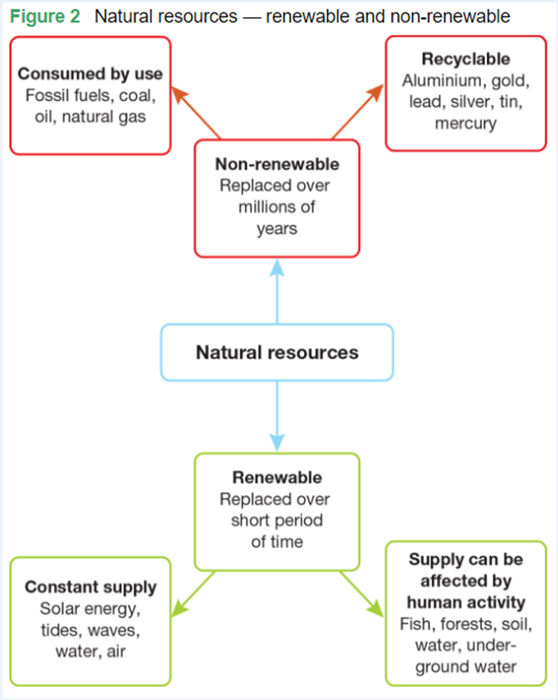

Activity 2 - Water as a resource: How much water is available for use?


Study the diagram above and answer the following questions:
Choose 4 sources of water and describe how they may be used.
Make a prediction about how global warming will affect our use of these sources of water
Discuss why water in glaciers, ice caps and groundwater might be hard to access.

Map Symbols:

Map symbols are icons or graphics located in a key or legend on the side of a map. They represent different features, such as rivers, mountains, roads, and landmarks, making it easier to read and understand the map's information.

Check your understanding:

Why do we use map symbols?

- Apply- Explain Diverse Characteristics of Places.

<<1.2 Sustainable Use of Water.docx>> | Teachers please print in colour and A3

Figure 1. A map portraying the natural resources that each country has.

Using the Map and Legend in figure 1, answer the following questions:

Name three countries that have coal
1.
2.
3.

Name a country that has Minerals but no energy resources

List the energy resources and minerals in Australia
1.
2.
3.
4.
5.
6.
7.
8.
9.

Using your ePen, draw a map symbol of a mineral that is not listed in the legend.

Research and list which countries have that mineral.

- Review- Exit Ticket

In pairs, discuss how we can use more renewable resources in Australia. Share your answers with the rest of class.

Extension - Map and Data Analyses: More detailed maps of Australia's minerals and energy resource.

Have a look at the following two maps and see if you can locate regions of Australia that produce a lot of mineral resources and a lot of energy resources







 | Level 6 | Level 7 | Level 8 | Level 9 | Level 10 | Level 11
1.1 Characteristics of place | I can identify diverse characteristics of places. | I can explain diverse characteristics of places. | I can explain processes that influence characteristics of places. | I can predict changes in the characteristics of places over time. | I can identify the implications of change for the future. | I can synthesise multiple data sources to provide analysis about the predicted changes.
2.1 Map and Data Analyses | I can identify the key features of a map (BOLTSS). | I can use geographical language to interpret increases, decreases or trends in maps, graphs, charts, or tables. | I can describe patterns, quantify them, and point out exceptions in maps, graphs, charts, or tables. | I can use social, historical, environmental, economic, political or technological factors (SHEEPT) to explain trends in maps, graphs, charts, or tables. | I can analyse relationships between multiple sources of geographical data. | I can analyse and draw reasoned conclusions from independently collected sources of geographical data.

1.3 Australia's Natural Resources
Saturday, 16 June 2018
12:01 PM
Learning intention | To explain the importance of natural resources to Australia
Success criteria | I can identify major energy resources in regions of Australia  I can explain and describe the use and importance of resources in Australia  I can appraise my knowledge of Australia's resources with a peer or family member
Content for Self-Assessment | Place & Map and Data Analyses

- Engage: Which natural resources are abundant in Australia?



Vocabulary:
Hydroelectric = power produced by water flowing through a turbine. To create hydroelectricity, a dam must be built across a large river
Basin = a depression in the Earth's surface
Crude oil = oil that has not been refined yet into products like petrol for cars
Deposit = places where there are large concentrations of a resource, e.g. a coal deposit of a uranium deposit
Bauxite = a mineral that is used to make aluminium

Map Task:
Zoom into the map to highlight the following natural resource regions of Australia with your ePen:
- 1) Hunter and La Trobe coal valleys
- 2) North West Shelf gas region
- 3) Snowy Mountains hydroelectric resources
- 4) Bass Strait wind and gas resources
- 5) Coal basins of Queensland
- 6) Hydroelectric resources of Tasmania

- Discover- Australia's resources
Australia has more natural resources per head of population than any other country in the world. The main reason for this is that we have a small population in a very large country.

Minerals
Australia is rich in mineral resources. The Pilbara region in Western Australia, for example, has some of the largest reserves of iron ore in the world. Australia also produces many other minerals, including silver, copper, nickel and tin.
Australia is the world’s:
• largest exporter of iron ore, bauxite, lead, diamonds, zinc ores and mineral sands
• second-largest exporter of alumina (processed from bauxite and then turned into aluminium)
• third-largest exporter of gold.

Soils
Australia has generally poor soils, especially when compared with those found in other continents such as North America and Europe. Most Australian soils are low in nutrients, and in some parts of the continent, particularly the more arid areas, high salt content is also a problem. Most parts of Australia are suitable only for sheep and cattle grazing, rather than intensive agriculture, owing to low rainfall and poor soils.
There are regions of good soil scattered throughout Australia. These include soils formed from volcanic rock, such as those on the Darling Downs in Queensland and around Orange in New South Wales, and alluvial soils (found in river valleys).



Natural scenery
Australia’s spectacular scenery attracts tourists from all over the world, particularly to those sites that are on the World Heritage List. This means that they are recognised as being of global importance due to their great natural or cultural significance.

Forests
Apart from Antarctica, which has no trees, Australia is the world’s least forested continent. The most common vegetation in Australia is woodland and shrubland. Before European occupation, about nine per cent of Australia was forested. Today, about five per cent of the country is forested. Even though Australia exports timber products, it also imports a lot of timber, particularly softwoods such as pine.




- Apply- Answer the questions below
- List the main mineral resources produced in Australia.

- Refer to the case study of the Pilbara:
- Where does Australia's main iron ore production take place?

- What is the main use of iron ore?

- Why is there strong demand overseas for Australian iron ore?

- Why are many Australian soils suitable only for grazing?

- To which region of the world do most of Australia's resources go?

- What type of energy resources is most abundant in Australia?

- How does mining affect the environment. Create a flow chart, or fill in the template below (NB: use your ePen for this task. Alternatively this will need to be saved and opened in a new program)



- Review and Reflect
In pairs quiz each other on the following questions (answer below - you'll have to scroll a bit - no peeking!)
- Where in Australia are Australia's major energy resource regions and what is produced in each region?
- What resources does Australia export to the rest of the world?
- Who are the main buyers of Australian resource exports?
- What are the definitions of:
  - Hydroelectric
  - Crude oil
  - Basin
  - Deposit
  - Bauxite

Do you think Australia can rely on only the resources it has or Do you think we need help from other countries? Why?

Review answers
- Coal - La Trobe Valley in Victoria; Hunter Valley in NSW; several major coal deposits in Queensland
  - Gas - North West Shelf; Bass Strait; Timor Sea
  - Hydroelectricity - Snowy Mountains; Western Tasmania
  - Uranium - eastern parts of South Australia; far-north Northern Territory e.g. Jabiluka
  - Wind - southern Victoria; Bass Strait; eastern parts of NSW
- Iron Ore, Bauxite, Coal, Gold, Zinc, Lead, Diamonds
- China, Japan, EU, India, South Korea, other parts of Asia
- Hydroelectric = power produced by water flowing through a turbine. To create hydroelectricity, a dam must be built across a large river
Basin = a depression in the Earth's surface
Crude oil = oil that has not been refined yet into products like petrol for cars
Deposit = places where there are large concentrations of a resource, e.g. a coal deposit of a uranium deposit
Bauxite = a mineral that is used to make aluminium

1.4 How does water change places?
Wednesday, 30 October 2024
4:12 PM
How Does Water Change Places?

Learning intention | To describe and explain how the movement of water affects the landscape.  To describe and explain river erosion, deposition and meandering.  To understand how river courses change over time, according to modern science.  To understand how river courses change over time according to indigenous cultures.
Success criteria | I can define and explain erosion, deposition and meandering.  I can explain how moving water can change a landscape.  I can create a flow diagram based on the creation of the Grand Canyon  I can annotate a geographical image

ENGAGE: Aboriginal and Torres Strait Islander Perspective on forming rivers and landscapes

Watch the following video and answer the questions below:
Awakening Of The Rainbow Serpent (6mins)


What did the Earth look like before the Rainbow Serpent changed everything?

Explain how the Rainbow Serpent formed rivers

Explain how the Rainbow Serpent formed hills and mountains



Study the image above of the Murray River, and explain how the river may have been formed according to the Dreamtime perspective of the Rainbow Serpent. Write your answer below.

Remember, this is only one perspective on the formation of waterways.

Vocabulary – In this topic you will need to understand relevant terms.
Provide a definition of each of the following, with reference to a river.
  - Meander

  - Erode or Erosion

  - Sediment

  - Water Flow

  - Barren

Now use each of these terms in a separate sentence to show your understanding

DISCOVER: How Rivers Change Their Course Over Time
Rivers don’t always stay in the same place; they can change their path over time. This happens because of natural processes like erosion and deposition, and sometimes because of human activity or changes in the climate. Here’s how it works:
1. Erosion and Deposition


As rivers flow, they carry away dirt, rocks, and sand from one place to another. This is called erosion. On the outside of a river bend, where the water flows fast, the river erodes the land. On the inside of a bend, where the water moves slower, the river drops off the dirt and sand it’s carrying. This process builds up new land, creating point bars on the inside of bends, while the outside of bends keeps getting eroded and the river curves more. Over time, this creates winding curves called meanders.
2. Meandering


Rivers often end up winding back and forth across the land. The more the river curves, the more erosion happens on the outside of the bends, and more sand and dirt build up on the inside of the bends. This makes the river bend even more. As time passes, these bends can get bigger and bigger.
3. Oxbow Lakes
Sometimes, a river’s curve can get so big that it forms a narrow strip of land, and during a flood or strong current, the river might break through this narrow part and find a quicker, shorter path. When this happens, the old bend is left behind and can form a shape like a horseshoe, called an oxbow lake.
4. Flooding
Floods can also change the river's path. When rivers overflow, they can carve new channels, move dirt and rocks, or even create new paths. Floods are one of the fastest ways rivers can change where they go.



5. Human Influence
People can also change rivers. Things like dams, roads, and buildings can block or change the river’s path. When humans do this, it can make rivers change direction more quickly or in ways that wouldn’t happen naturally.



6. Climate Change
Changes in weather, like more rain or longer droughts, can affect how rivers move. More rain can cause floods, which can change the river’s path. Less rain might make the river flow more slowly and change less often.



In Summary:
Rivers change their course over time because of erosion, where they wear down the land and move dirt and rocks around. This makes rivers bend, create oxbow lakes, and sometimes change their path after floods. Humans and changes in the weather can also speed up or affect these changes.

Watch the following video and answer the questions below:
Why Do Rivers Curve?



Video Questions:
  - In your own words, explain how a muskrat might contribute to changing the direction of a river.

  - Explain how deeper curves occur within a flowing river.

  - How does an ox-bow lake or billabong form?

APPLY: Mini Case Study - The Grand Canyon
How Was the Grand Canyon Formed? (4.28mins)


After you watch the video, create an 8 step Flow Diagram to show how the Grand Canyon was formed.

Teacher note: students should include the following:

  - Mazatzal Mountains
  - Erosion of these mountains
  - Ancient oceans, deposition and layering
  - Tectonic uplift creates Rocky Mountains
  - Colorado River created by snowmelt
  - Descending river water, 0.5 million tonnes of transported material daily
  - Erosion by the Colorado River
  - Ice, rain and snow erosion of the canyon walls.

Annotate the image below of a section of the Grand Canyon, including the Colorado River. Be sure to indicate the following:
  - Erosion
  - Layering or stratification
  - Deposition
  - Meandering



1.1 The Water Cycle
Lesson Focus: What is the water cycle?

Learning intention | To describe and explain types of rainfall and the stages of the water cycle.  To describe different types of rainfall.  To describe Australia's rainfall distribution using PQE method.
Success criteria | I can explain the water cycle.  I can explain and distinguish the different types of rainfall  I can explain Australia's rainfall distribution using PQE method.
Content for Self-Assessment | Map and Data Analyses

- Engage: Play and Watch (hook)

The Great Aqua Adventure: Crash Course Kids #24.1



- Discover and develop

Water is one of our most precious environmental resources. Without it, nothing can survive. It is an essential, renewable resource that occurs naturally on Earth. It can exist as a solid (such as ice in a glacier), a liquid (such as water in a river) or a gas (such as steam). Fresh water is an available resource when in liquid form and a potential resource as a gas or a solid. Liquid water is constantly being recycled through the atmosphere, rivers and oceans in a natural system known as the water cycle.

Write a definition for each of these words: precipitation, condensation and evaporation.
Word | Definition
Precipitation
Condensation
Evaporation
Transpiration

Draw the Water Cycle in your work books.


Include the following words in your picture:

Evaporation
Precipitation
Condensation
Transpiration

Take a look at the Urban Water Cycle.


Answer the following questions:
- Describe the connection between fresh water, storm water and waste water.

- What are the potential effects on people and the environment when using this kind of water management?

- What is one similarity between the Water Cycle and the Urban Water Cycle

- What is one difference between the Water Cycle and the Urban Water Cycle

- Apply
PQE stands for Pattern, Quantify and Exception. When looking at a map or graph, in order to determine the trends and distribution shown, you can use this method to complete your analysis of the graph.

Referring to the graph below - complete a PQE and use the table to guide you in completing it.
P - requires you to look at the pattern and trends in the information. Think: if you had to describe general consistencies, how would you describe that?
Q - requires you to numerically justify the pattern you have observed using data from the information provided. Think: if you had to support the pattern you identified, what data could you include to support it?
E - requires you to find the exceptions to the pattern, what are the outliers? Think: if there is a pattern that isn't consistent with the rest, what is it?



PQE | Sentence Starters (select one) | Your Response
Pattern | - The pattern shown…  - The trend of…  - Consistent across Australia is…
Quantify | -This is shown by…  -This is evident as…
Exception | - The exception to this is…  - The outlier to this is…

- Review and Reflect

Kahoot - Fun water facts https://create.kahoot.it/v2/share/amazing-water-facts/bb115294-ba7c-4388-bd2f-53666deb21d8

Additional Activities- Extension Water Cycle Game - Fun, 20 minutes, gets students moving:
<<Water Cycle Game.pdf>>

1.2 Sustainable use of water

Learning Intention | Explain different types of resources as either renewable or non-renewable  Describe the classification of water resources  Analyse maps and other geographic data to learn more about water resources
Success criteria | I can classify resources as renewable and non-renewable.  I can explain why water is considered a renewable resource.  I can make connections between climate factors (temperature and precipitation), water resource accessibility, and population density.  I can describe patterns, quantify them, and point out exceptions in maps, graphs, charts, or tables.
Content for Self-Assessment | Place and Map & Data Analyses

- Engage: Play Tragedy of the Commons Game https://www.sciencefriday.com/educational-resources/one-for-all-a-natural-resources-game/

Arrange students in a circle, explain the game simulates shared resources, place 30 chips in the centre, read the rules, play music and let students take chips, stop music and double remaining chips (max 30), repeat until pool is depleted or strategies form, discuss outcomes, restart if needed, allow strategy discussion, add new students to simulate growth, continue and observe, finish with a discussion on real-world resource use.

- Discover and Develop

Activity 1 - What is a resource?

Definitions:
Resource
Natural resource
Renewable resource
Non-renewable resource
Recyclable resource

Diagram:



Activity 2 - Water as a resource: How much water is available for use?


Study the diagram above and answer the following questions:
Choose 4 sources of water and describe how they may be used.
Make a prediction about how global warming will affect our use of these sources of water
Discuss why water in glaciers, ice caps and groundwater might be hard to access.

Map Symbols:

Map symbols are icons or graphics located in a key or legend on the side of a map. They represent different features, such as rivers, mountains, roads, and landmarks, making it easier to read and understand the map's information.

Check your understanding:

Why do we use map symbols?

- Apply- Explain Diverse Characteristics of Places.

<<1.2 Sustainable Use of Water.docx>> | Teachers please print in colour and A3

Figure 1. A map portraying the natural resources that each country has.

Using the Map and Legend in figure 1, answer the following questions:

Name three countries that have coal
1.
2.
3.

Name a country that has Minerals but no energy resources

List the energy resources and minerals in Australia
1.
2.
3.
4.
5.
6.
7.
8.
9.

Using your ePen, draw a map symbol of a mineral that is not listed in the legend.

Research and list which countries have that mineral.

- Review- Exit Ticket

In pairs, discuss how we can use more renewable resources in Australia. Share your answers with the rest of class.

Extension - Map and Data Analyses: More detailed maps of Australia's minerals and energy resource.

Have a look at the following two maps and see if you can locate regions of Australia that produce a lot of mineral resources and a lot of energy resources







 | Level 6 | Level 7 | Level 8 | Level 9 | Level 10 | Level 11
1.1 Characteristics of place | I can identify diverse characteristics of places. | I can explain diverse characteristics of places. | I can explain processes that influence characteristics of places. | I can predict changes in the characteristics of places over time. | I can identify the implications of change for the future. | I can synthesise multiple data sources to provide analysis about the predicted changes.
2.1 Map and Data Analyses | I can identify the key features of a map (BOLTSS). | I can use geographical language to interpret increases, decreases or trends in maps, graphs, charts, or tables. | I can describe patterns, quantify them, and point out exceptions in maps, graphs, charts, or tables. | I can use social, historical, environmental, economic, political or technological factors (SHEEPT) to explain trends in maps, graphs, charts, or tables. | I can analyse relationships between multiple sources of geographical data. | I can analyse and draw reasoned conclusions from independently collected sources of geographical data.

1.3 Australia's Natural Resources
Saturday, 16 June 2018
12:01 PM
Learning intention | To explain the importance of natural resources to Australia
Success criteria | I can identify major energy resources in regions of Australia  I can explain and describe the use and importance of resources in Australia  I can appraise my knowledge of Australia's resources with a peer or family member
Content for Self-Assessment | Place & Map and Data Analyses

- Engage: Which natural resources are abundant in Australia?



Vocabulary:
Hydroelectric = power produced by water flowing through a turbine. To create hydroelectricity, a dam must be built across a large river
Basin = a depression in the Earth's surface
Crude oil = oil that has not been refined yet into products like petrol for cars
Deposit = places where there are large concentrations of a resource, e.g. a coal deposit of a uranium deposit
Bauxite = a mineral that is used to make aluminium

Map Task:
Zoom into the map to highlight the following natural resource regions of Australia with your ePen:
- 1) Hunter and La Trobe coal valleys
- 2) North West Shelf gas region
- 3) Snowy Mountains hydroelectric resources
- 4) Bass Strait wind and gas resources
- 5) Coal basins of Queensland
- 6) Hydroelectric resources of Tasmania

- Discover- Australia's resources
Australia has more natural resources per head of population than any other country in the world. The main reason for this is that we have a small population in a very large country.

Minerals
Australia is rich in mineral resources. The Pilbara region in Western Australia, for example, has some of the largest reserves of iron ore in the world. Australia also produces many other minerals, including silver, copper, nickel and tin.
Australia is the world’s:
• largest exporter of iron ore, bauxite, lead, diamonds, zinc ores and mineral sands
• second-largest exporter of alumina (processed from bauxite and then turned into aluminium)
• third-largest exporter of gold.

Soils
Australia has generally poor soils, especially when compared with those found in other continents such as North America and Europe. Most Australian soils are low in nutrients, and in some parts of the continent, particularly the more arid areas, high salt content is also a problem. Most parts of Australia are suitable only for sheep and cattle grazing, rather than intensive agriculture, owing to low rainfall and poor soils.
There are regions of good soil scattered throughout Australia. These include soils formed from volcanic rock, such as those on the Darling Downs in Queensland and around Orange in New South Wales, and alluvial soils (found in river valleys).



Natural scenery
Australia’s spectacular scenery attracts tourists from all over the world, particularly to those sites that are on the World Heritage List. This means that they are recognised as being of global importance due to their great natural or cultural significance.

Forests
Apart from Antarctica, which has no trees, Australia is the world’s least forested continent. The most common vegetation in Australia is woodland and shrubland. Before European occupation, about nine per cent of Australia was forested. Today, about five per cent of the country is forested. Even though Australia exports timber products, it also imports a lot of timber, particularly softwoods such as pine.




- Apply- Answer the questions below
- List the main mineral resources produced in Australia.

- Refer to the case study of the Pilbara:
- Where does Australia's main iron ore production take place?

- What is the main use of iron ore?

- Why is there strong demand overseas for Australian iron ore?

- Why are many Australian soils suitable only for grazing?

- To which region of the world do most of Australia's resources go?

- What type of energy resources is most abundant in Australia?

- How does mining affect the environment. Create a flow chart, or fill in the template below (NB: use your ePen for this task. Alternatively this will need to be saved and opened in a new program)



- Review and Reflect
In pairs quiz each other on the following questions (answer below - you'll have to scroll a bit - no peeking!)
- Where in Australia are Australia's major energy resource regions and what is produced in each region?
- What resources does Australia export to the rest of the world?
- Who are the main buyers of Australian resource exports?
- What are the definitions of:
  - Hydroelectric
  - Crude oil
  - Basin
  - Deposit
  - Bauxite

Do you think Australia can rely on only the resources it has or Do you think we need help from other countries? Why?

Review answers
- Coal - La Trobe Valley in Victoria; Hunter Valley in NSW; several major coal deposits in Queensland
  - Gas - North West Shelf; Bass Strait; Timor Sea
  - Hydroelectricity - Snowy Mountains; Western Tasmania
  - Uranium - eastern parts of South Australia; far-north Northern Territory e.g. Jabiluka
  - Wind - southern Victoria; Bass Strait; eastern parts of NSW
- Iron Ore, Bauxite, Coal, Gold, Zinc, Lead, Diamonds
- China, Japan, EU, India, South Korea, other parts of Asia
- Hydroelectric = power produced by water flowing through a turbine. To create hydroelectricity, a dam must be built across a large river
Basin = a depression in the Earth's surface
Crude oil = oil that has not been refined yet into products like petrol for cars
Deposit = places where there are large concentrations of a resource, e.g. a coal deposit of a uranium deposit
Bauxite = a mineral that is used to make aluminium

1.4 How does water change places?
Wednesday, 30 October 2024
4:12 PM
How Does Water Change Places?

Learning intention | To describe and explain how the movement of water affects the landscape.  To describe and explain river erosion, deposition and meandering.  To understand how river courses change over time, according to modern science.  To understand how river courses change over time according to indigenous cultures.
Success criteria | I can define and explain erosion, deposition and meandering.  I can explain how moving water can change a landscape.  I can create a flow diagram based on the creation of the Grand Canyon  I can annotate a geographical image

ENGAGE: Aboriginal and Torres Strait Islander Perspective on forming rivers and landscapes

Watch the following video and answer the questions below:
Awakening Of The Rainbow Serpent (6mins)


What did the Earth look like before the Rainbow Serpent changed everything?

Explain how the Rainbow Serpent formed rivers

Explain how the Rainbow Serpent formed hills and mountains



Study the image above of the Murray River, and explain how the river may have been formed according to the Dreamtime perspective of the Rainbow Serpent. Write your answer below.

Remember, this is only one perspective on the formation of waterways.

Vocabulary – In this topic you will need to understand relevant terms.
Provide a definition of each of the following, with reference to a river.
  - Meander

  - Erode or Erosion

  - Sediment

  - Water Flow

  - Barren

Now use each of these terms in a separate sentence to show your understanding

DISCOVER: How Rivers Change Their Course Over Time
Rivers don’t always stay in the same place; they can change their path over time. This happens because of natural processes like erosion and deposition, and sometimes because of human activity or changes in the climate. Here’s how it works:
1. Erosion and Deposition


As rivers flow, they carry away dirt, rocks, and sand from one place to another. This is called erosion. On the outside of a river bend, where the water flows fast, the river erodes the land. On the inside of a bend, where the water moves slower, the river drops off the dirt and sand it’s carrying. This process builds up new land, creating point bars on the inside of bends, while the outside of bends keeps getting eroded and the river curves more. Over time, this creates winding curves called meanders.
2. Meandering


Rivers often end up winding back and forth across the land. The more the river curves, the more erosion happens on the outside of the bends, and more sand and dirt build up on the inside of the bends. This makes the river bend even more. As time passes, these bends can get bigger and bigger.
3. Oxbow Lakes
Sometimes, a river’s curve can get so big that it forms a narrow strip of land, and during a flood or strong current, the river might break through this narrow part and find a quicker, shorter path. When this happens, the old bend is left behind and can form a shape like a horseshoe, called an oxbow lake.
4. Flooding
Floods can also change the river's path. When rivers overflow, they can carve new channels, move dirt and rocks, or even create new paths. Floods are one of the fastest ways rivers can change where they go.



5. Human Influence
People can also change rivers. Things like dams, roads, and buildings can block or change the river’s path. When humans do this, it can make rivers change direction more quickly or in ways that wouldn’t happen naturally.



6. Climate Change
Changes in weather, like more rain or longer droughts, can affect how rivers move. More rain can cause floods, which can change the river’s path. Less rain might make the river flow more slowly and change less often.



In Summary:
Rivers change their course over time because of erosion, where they wear down the land and move dirt and rocks around. This makes rivers bend, create oxbow lakes, and sometimes change their path after floods. Humans and changes in the weather can also speed up or affect these changes.

Watch the following video and answer the questions below:
Why Do Rivers Curve?



Video Questions:
  - In your own words, explain how a muskrat might contribute to changing the direction of a river.

  - Explain how deeper curves occur within a flowing river.

  - How does an ox-bow lake or billabong form?

APPLY: Mini Case Study - The Grand Canyon
How Was the Grand Canyon Formed? (4.28mins)


After you watch the video, create an 8 step Flow Diagram to show how the Grand Canyon was formed.

Teacher note: students should include the following:

  - Mazatzal Mountains
  - Erosion of these mountains
  - Ancient oceans, deposition and layering
  - Tectonic uplift creates Rocky Mountains
  - Colorado River created by snowmelt
  - Descending river water, 0.5 million tonnes of transported material daily
  - Erosion by the Colorado River
  - Ice, rain and snow erosion of the canyon walls.

Annotate the image below of a section of the Grand Canyon, including the Colorado River. Be sure to indicate the following:
  - Erosion
  - Layering or stratification
  - Deposition
  - Meandering



